Visoka škola strukovnih studija

 za informacione i komunikacione

 Tehnologije

REDDY

<https://reddy.netlify.com/>

Teodora Nedeljkovic, 5/18

Smer: Internet Tehnologije

Modul: Web programiranje

Predmet: Web programiranje 2

Contents

1  UVOD 3

1.1  Korišćene tehnologije I template 3

1.2  Mapa sajta 3

2 FUNKCIONALNOSTI 4

2.1 Funkcionalnosti 4

3 KODOVI 14

3.1 VIEWS 14

3.11 index.html 14

3.13 movies.html 18

3.14 reviews.html 22

3.15 watchlist.html 26

3.16 contact.html 29

3.17 author.html 32

3.2 JSON 35

3.21 Genres.json 36

3.22 movies.json 36

3.23 news.json 48

3.24 reviews.json 49

3.25 topMovies.json 52

3.26 topReviewers.json 53

3.4 JS 55

3.5 SCSS 72

# 1  UVOD

## 1.1  Korišćene tehnologije I template

Radjeno je korišćenjem: HTML, JavaScript,Jquery, SASS/CSS, i XML u Sublime text editoru.

Template je ručno pisan.

## 1.2  Mapa sajta

<?xml version="1.0" encoding="UTF-8"?>

<urlset xmlns="http://www.sitemaps.org/schemas/sitemap/0.9" xmlns:xsi="http://www.w3.org/2001/XMLSchema-instance" xsi:schemaLocation="http://www.sitemaps.org/schemas/sitemap/0.9

 http://www.sitemaps.org/schemas/sitemap/0.9/sitemap.xsd">

    <url>

        <loc>https://reddy.netlify.com/index.html</loc>

        <lastmod>2020-03-28</lastmod>

        <changefreq>monthly</changefreq>

        <priority>0.8</priority>

    </url>

    <url>

        <loc>https://reddy.netlify.com/reviews.html</loc>

        <lastmod>2020-03-28</lastmod>

        <changefreq>weekly</changefreq>

        <priority>0.9</priority>

    </url>

    <url>

        <loc>https://reddy.netlify.com/movies.html</loc>

        <lastmod>2020-03-28</lastmod>

        <changefreq>daily</changefreq>

        <priority>1</priority>

    </url>

    <url>

        <loc>https://reddy.netlify.com/watchlist.html</loc>

        <lastmod>2020-03-28</lastmod>

        <changefreq>monthly</changefreq>

        <priority>0.8</priority>

    </url>

    <url>

        <loc>https://reddy.netlify.com/contact.html</loc>

        <lastmod>2020-03-28</lastmod>

        <changefreq>yearly</changefreq>

        <priority>0.2</priority>

    </url>

    <url>

        <loc>https://reddy.netlify.com/author.html</loc>

        <lastmod>2020-03-28</lastmod>

        <changefreq>yearly</changefreq>

        <priority>0.1</priority>

    </url>

</urlset>

# 2 FUNKCIONALNOSTI

## 2.1 Funkcionalnosti

**Index stranica**

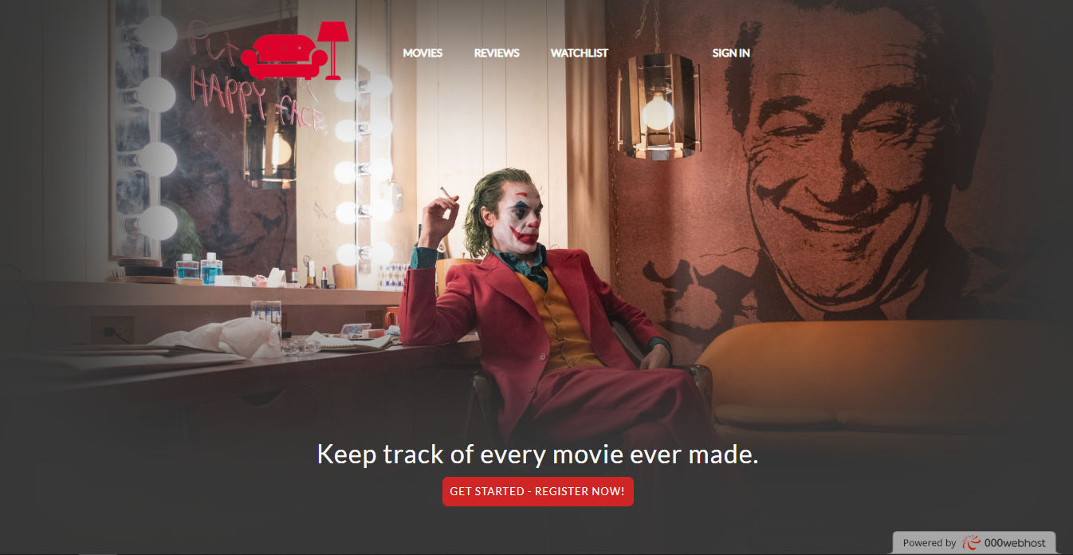

 U gornjem desnom uglu se nalazi link za simulaciju sign in-s korisnika.

Prilikom upisivanja podataka I prolazenja regularnih izraza, username se zapisuje u local storage. Klikom na isgn out sve se iz local storage brise.

Kada je korisnik “ulogovan” pisace njegov username kao deo menija.

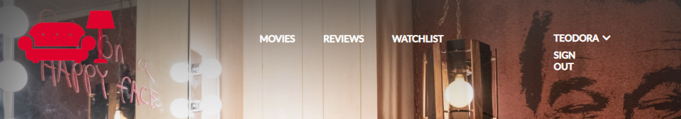

Zatim se nalazi statički blok koji vodi ka ostalim stranicama. I link ka pop za simulaciju registracije.

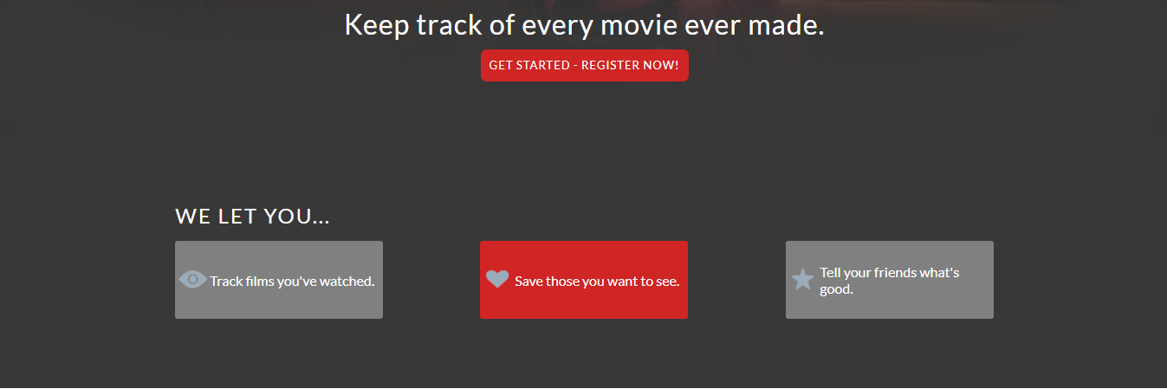

Registracioni pop-up blok. Upisivanje u local storage podataka.

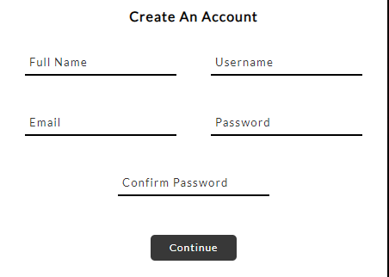

Sign in pop up blok.

Greske pri klik na dugme se ispisuju, isto kao I za registracioni blok.

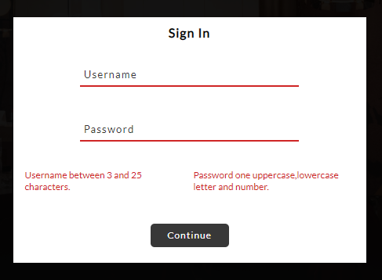

Staticni blok koji ‘vodi ’ka ‘anketi’.

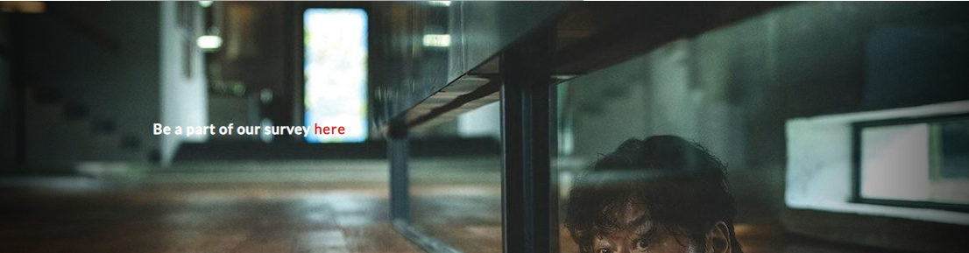

Iz jsona uzete recenzije, username, ime filma, tekst, datum pisanja.

Klik na see more ako je tekst duzi od 250 karaktera.

Sa desne strane iz jsona uzeti korisnici sa najvise napisanih recenzija.

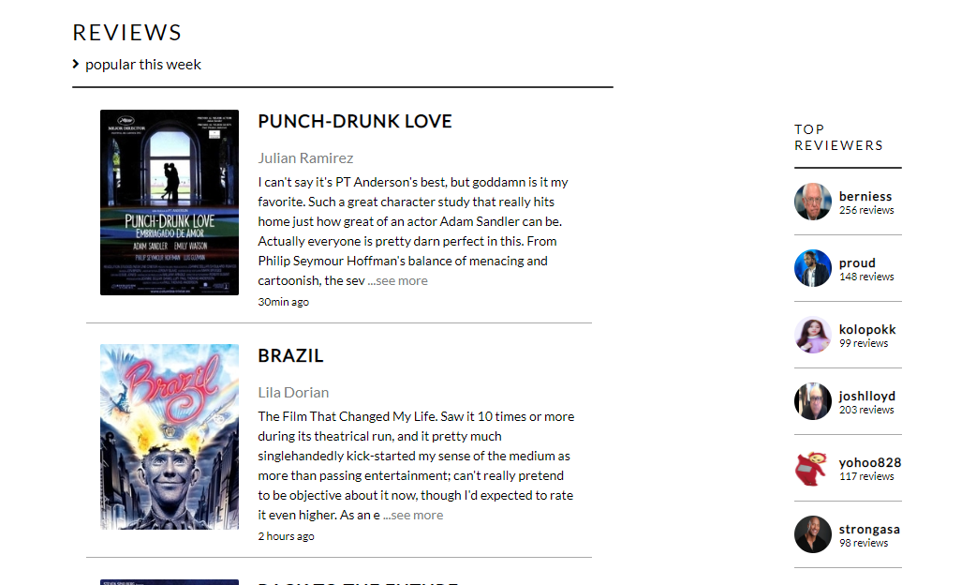

News json. 3 bloka sa slikom, imenom I tekstom.

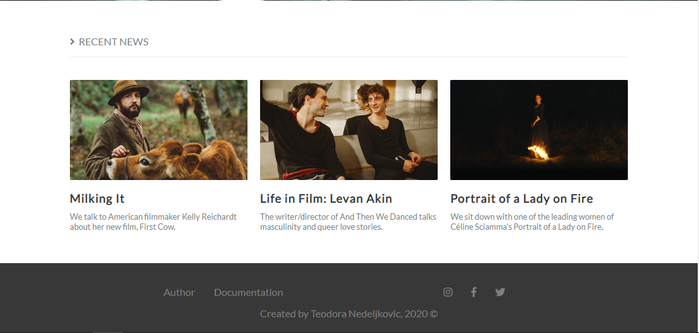

Futer isti na svakoj stranici.

**MOVIES STRANICA**

Time out slider sa dve preporuke filma. Slike se iz jsona uzimaju.

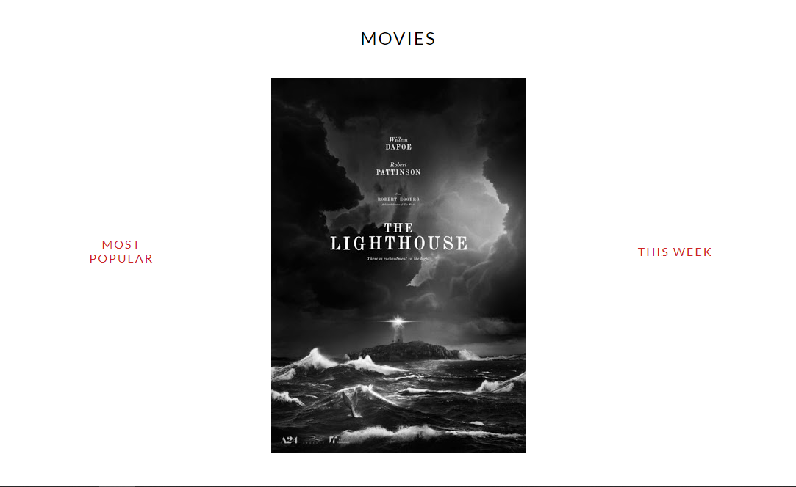

Prikaz svih slika iz jsona, funkcionalnost sortiranje prema najnonijem ili najstarijem filmu.

Prema odabiru zanra, ili se moze pretraziti prema imenu. Tasterom enter ili klikom na lupicu.

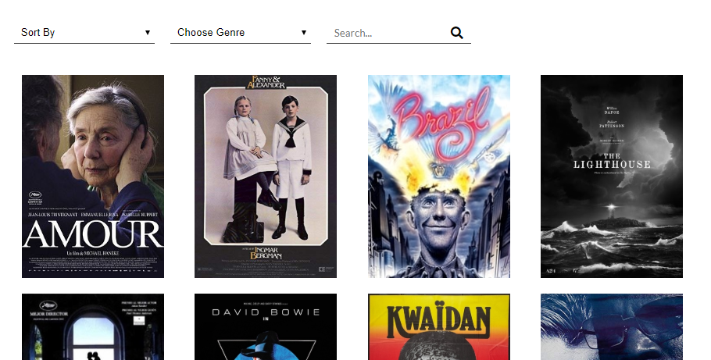

Klikom na bilo koji od filma se pojavljuje info blok sa informacijiama o ljudima koji su radili na njemu, naslovu,godini izdanja,sinopsisu…

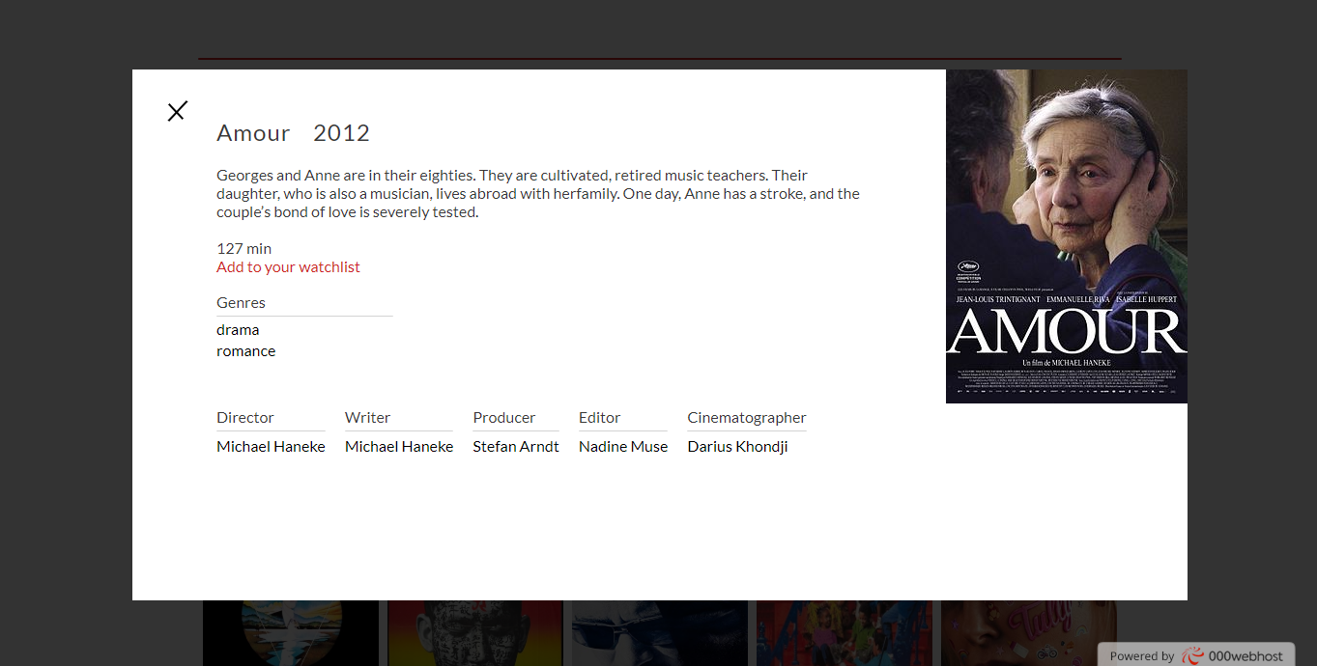

Klik za dodavanje u watchlistu se ovde nalazi.

Ako osoba nije prijavljenapisace da treba da se prijavi.

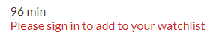

**REVIEWS STRANICA**

Najnovijih 7 filmova za koje su napisane recenzije.

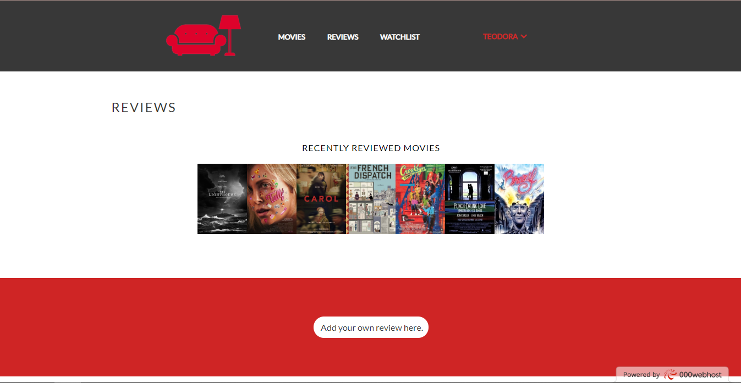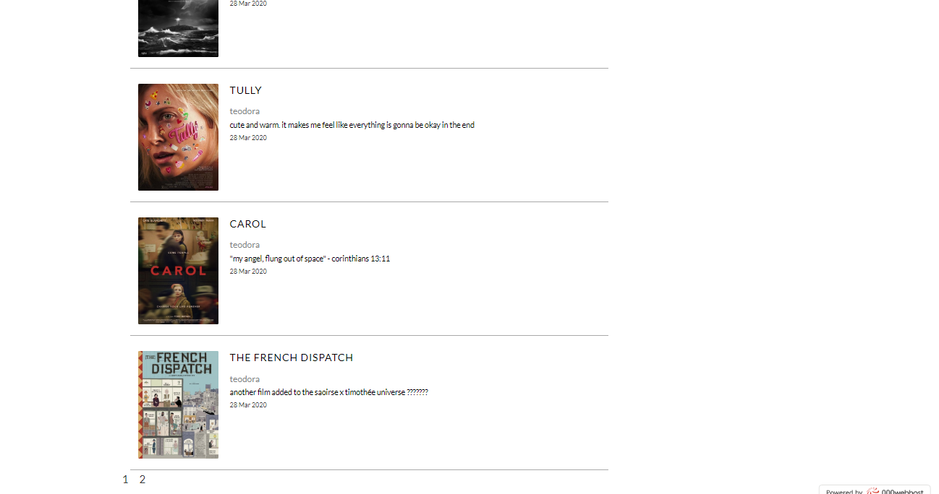

Sve recenzije napisane, iz JSON-a.Informacije o tome ko je napisao, sta I za koji film.

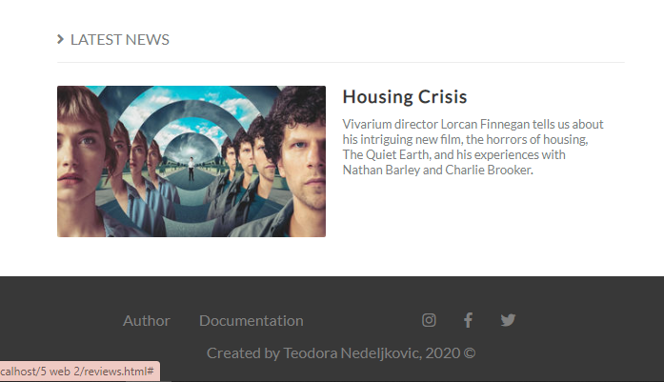

Statički blok sa vestima.

**WATCHLIST STRANICA**

Ako je korisnik ulogovan, a nema filmove u watchlisti nalazi se link ka stranici sa filmovima.

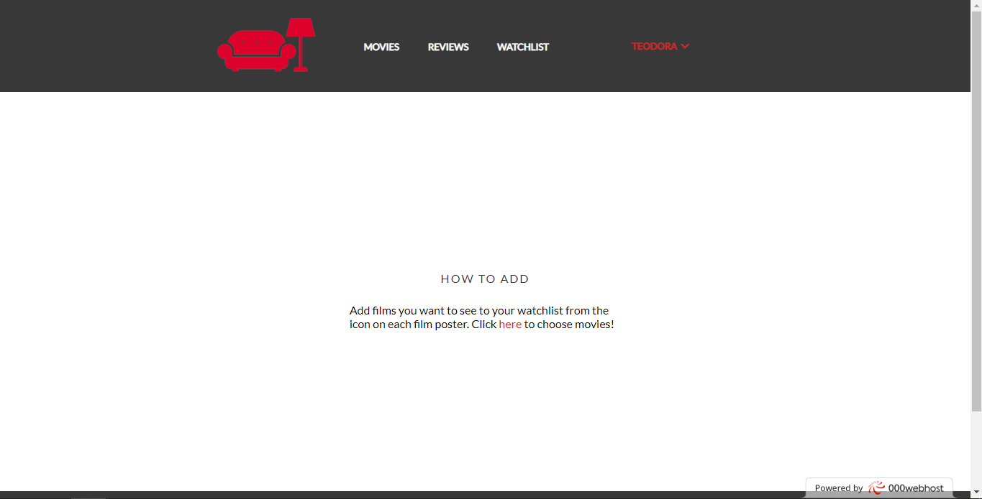

Filmovi iz watchliste korisnika I dugme X za brisanje filma iz liste.

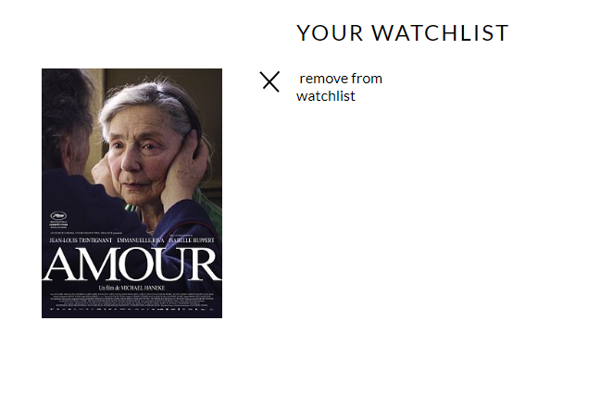

**CONTACT STRANICA**

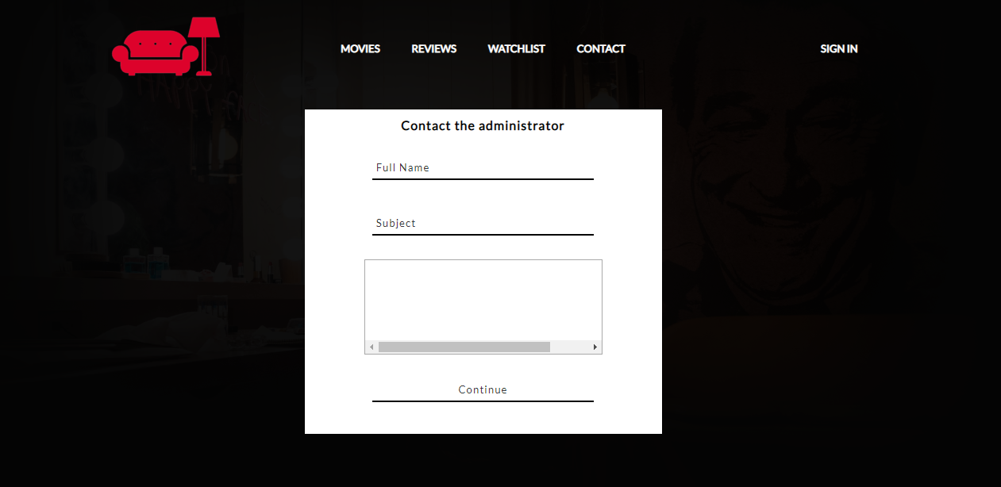

Ispisuju se greske ako ih ima pri kliku na continue

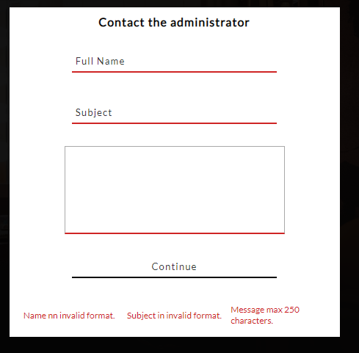

**AUTOR STRANICA**

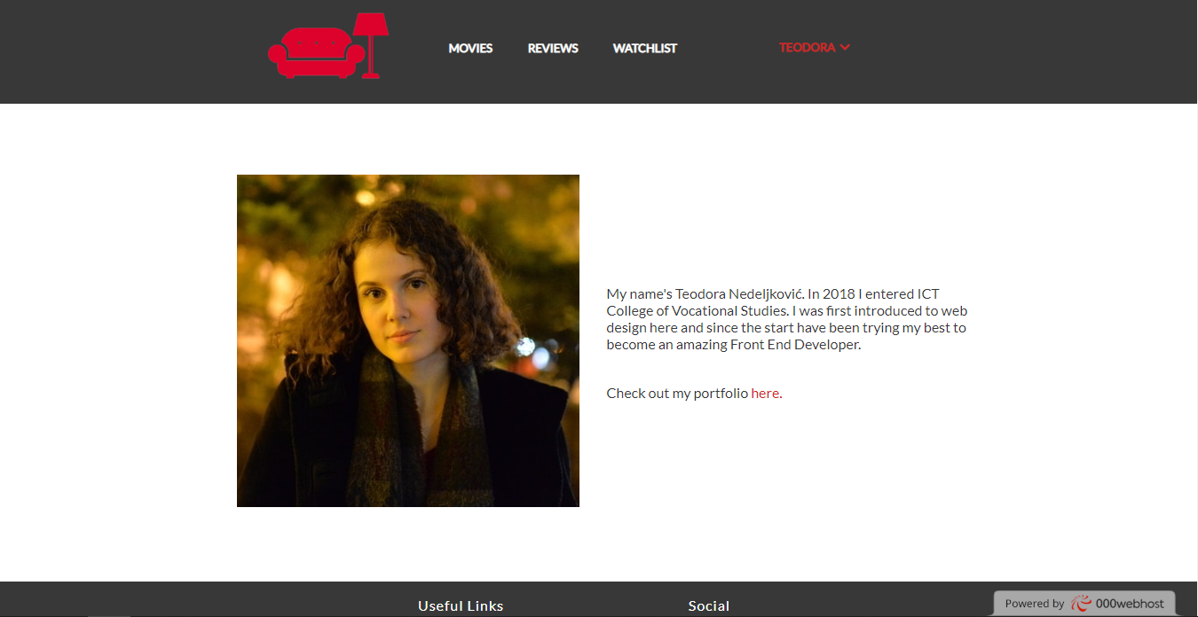

# 3 KODOVI

## 3.1 VIEWS

### 3.11 index.html

<!DOCTYPE html>

<html>

<head>

    <title>Reddy Home Page</title>

    <link rel="stylesheet" type="text/css" href="css/style.min.css"/>

    <link rel="stylesheet" href="https://use.fontawesome.com/releases/v5.4.1/css/all.css" integrity="sha384-5sAR7xN1Nv6T6+dT2mhtzEpVJvfS3NScPQTrOxhwjIuvcA67KV2R5Jz6kr4abQsz" crossorigin="anonymous"/>

    <meta charset="utf-8"/>

    <meta name="description" content=""/>

    <meta name="keywords" content=""/>

    <meta name="author" content=" Teodora Nedeljković"/>

    <meta name="viewport" content="width=device-width, initial-scale=1.0"/>

    <link rel="shortcut icon" href="img/favicon.ico"/>

</head>

<body>

    <div id="poster">

        <div id="header">

            <div class="wrapper">

                <div>

                    <a href="index.html"><img src="img/logo.png" alt="logo"></a>

                </div>

                <div>

                    <ul id="nav">

                        <li><a href="movies.html">movies</a></li>

                        <li><a href="reviews.html">reviews</a></li>

                        <li><a href="watchlist.html">watchlist</a></li>

                    </ul>

                    <div id="navSmall"><p>MENU</p>

                        <ul>

                            <li><a href="movies.html">movies</a></li>

                            <li><a href="reviews.html">reviews</a></li>

                            <li><a href="watchlist.html">watchlist</a></li>

                        </ul>

                    </div>

                </div>

                <div>

                    <ul id="account">

                    </ul>

                </div>

            </div>

        </div>

        <div id="posterTitle">

            <h1>Keep track of every movie ever made.</h1>

            <div>

                <a href="#" class="register">Get started - Register now!</a>

            </div>

        </div>

    </div>

    <div id="highlights">

        <div class="wrapper">

            <h2>WE LET YOU...</h2>

            <div id="highlightsBlock">

                <a href="movies.html" class="highlight watched">

                    <span class="icons icon-watched"></span>

                    <p>Track films you've watched.</p>

                </a>

                <a href="watchlist.html" class="highlight seen">

                    <span class="icons icon-seen"></span>

                    <p>Save those you want to see.</p>

                </a>

                <a href="reviews.html" class="highlight reviewed">

                    <span class="icons icon-reviewed"></span>

                    <p>Tell your friends what's good.</p>

                </a>

            </div>

        </div>

    </div>

    <div class="content">

        <div class="wrapper">

            <div id="reviews">

                <div class="title">

                    <h2>REVIEWS</h2>

                    <p><i class="fas fa-angle-right"></i>&nbsp;&nbsp;popular this week</p>

                </div>

                <hr/>

                <div id="reviewBlock">

                </div>

            </div>

            <div id="topReviewers">

                <h2>TOP REVIEWERS</h2>

                <hr/>

                <div id="topReviewersBlock">

                </div>

            </div>

        </div>

    </div>

    <div id="survey">

        <div class="wrapper">

            <div id="surveyBlock">

                <p>Be a part of our survey <a href='#'>here</a>!</p>

            </div>

        </div>

    </div>

    <div id="news">

        <div class="wrapper">

            <div class="title">

                <p><i class="fas fa-angle-right"></i>&nbsp;&nbsp;RECENT NEWS</p>

                <hr/>

            </div>

            <div id="newsBlock">

            </div>

        </div>

    </div>

    <div id="footer">

        <div id="rowFirst">

            <div>

                <ul>

                    <li><a href="author.html">Author</a></li>

                    <li><a href="documentation.pdf">Documentation</a></li>

                </ul>

            </div>

            <div id="social">

                <ul>

                    <li><a href="https://www.instagram.com" target="_blank"><i class="fab fa-instagram"></i></a></li>

                    <li><a href="https://www.facebook.com" target="_blank"><i class="fab fa-facebook-f"></i></a></li>

                    <li><a href="https://www.twitter.com" target="_blank"><i class="fab fa-twitter"></i></a></li>

                </ul>

                </div>

        </div>

        <div><p>Created by Teodora Nedeljkovic, 2020 &copy;</p></div>

    </div>

    <div id="signInBlock">

        <div class="formClose close">

            <span></span>

            <span></span>

        </div>

        <form method="POST" action="#" id="formSignIn">

            <div><h4>Sign In</h4></div>

            <div><input type="text" name="usernameSignIn" id="usernameSignIn" placeholder="Username"/></div>

            <div><input type="password" name="passwordSignIn" id="passwordSignIn" placeholder="Password"/></div>

            <div class="errorsBlock" id='signInErrorsBlock'>

            </div>

            <div><input type="button" name="dugmeSignIn" id="dugmeSignIn" value="Continue"></div>

        </form>

    </div>

    <div id="registerBlock">

        <div class="formClose close">

            <span></span>

            <span></span>

        </div>

        <form method="POST" action="#" id="formRegister">

            <div><h4>Create An Account</h4></div>

            <div><input type="text" name="fullName" id="fullName" placeholder="Full Name"/></div>

            <div><input type="text" name="usernameRegister" id="usernameRegister" placeholder="Username"/></div>

            <div><input type="email" name="emailRegister" id="emailRegister" placeholder="Email"/></div>

            <div><input type="password" name="passwordRegister" id="passwordRegister" placeholder="Password"/></div>

            <div><input type="password" name="passwordConfirm" id="passwordConfirm" placeholder="Confirm Password"/></div>

            <div class="errorsBlock" id='registerErrorsBlock'>

            </div>

            <div><input type="button" name="dugmeRegister" id="dugmeRegister" value="Continue"></div>

        </form>

    </div>

    <script type="text/javascript" src="assets/js/jquery.min.js"></script>

    <script type="text/javascript" src="assets/js/main.min.js"></script>

</body>

</html>

### 3.13 movies.html

<!DOCTYPE html>

<html>

<head>

    <title>Movies</title>

    <link rel="stylesheet" type="text/css" href="css/style.min.css"/>

    <link rel="stylesheet" href="https://use.fontawesome.com/releases/v5.4.1/css/all.css" integrity="sha384-5sAR7xN1Nv6T6+dT2mhtzEpVJvfS3NScPQTrOxhwjIuvcA67KV2R5Jz6kr4abQsz" crossorigin="anonymous"/>

    <meta charset="utf-8"/>

    <meta name="description" content=""/>

    <meta name="keywords" content=""/>

    <meta name="author" content=" Teodora Nedeljković"/>

    <meta name="viewport" content="width=device-width, initial-scale=1.0"/>

    <link rel="shortcut icon" href="img/favicon.ico"/>

</head>

<body>

    <div id="header">

        <div class="wrapper">

            <div>

                <a href="index.html"><img src="img/logo.png" alt="logo"></a>

            </div>

            <div>

                <ul id="nav">

                    <li><a href="movies.html">movies</a></li>

                    <li><a href="reviews.html">reviews</a></li>

                    <li><a href="watchlist.html">watchlist</a></li>

                </ul>

                <div id="navSmall"><p>MENU</p>

                    <ul>

                        <li><a href="movies.html">movies</a></li>

                        <li><a href="reviews.html">reviews</a></li>

                        <li><a href="watchlist.html">watchlist</a></li>

                    </ul>

                </div>

            </div>

            <div>

                <ul id="account">

                </ul>

            </div>

        </div>

    </div>

    <div id="movies">

        <div class="wrapper">

            <h2>movies</h2>

            <div id="topMovies">

                <h4>Most Popular</h4>

                <div id="topMoviesBlock">

                </div>

                <h4>This Week</h4>

            </div>

            <div id="manipulateMovies">

                <div id="sortFilterBlock" class="input-field">

                    <select name="sort" id="sortMovies" >

                        <option value="0">Sort By</option>

                        <option value="oldest">Oldest</option>

                        <option value="newest">Newest</option>

                    </select>

                    <select name="filter" id="filterMovies">

                        <option value="0">Choose Genre</option>

                        <option value="action">Action</option>

                        <option value="comedy">Comedy</option>

                        <option value="drama">Drama</option>

                        <option value="fantasy">Fantasy</option>

                        <option value="mystery">Mystery</option>

                        <option value="science fiction">Science Fiction</option>

                        <option value="horror">Horror</option>

                    </select>

                </div>

                <div id="search">

                    <input type="text" name="searchInput" id="searchInput" placeholder="Search..."/>

                    <a id="searchMovies" href="#"><i class="fas fa-search"></i></a>

                </div>

            </div>

            <div id="moviesBlock">

            </div>

            <div id="infoBlock">

            </div>

        </div>

    </div>

    <div id="footer">

        <div id="rowFirst">

            <div>

                <ul>

                    <li><a href="author.html">Author</a></li>

                    <li><a href="#">Documentation</a></li>

                </ul>

            </div>

            <div id="social">

                <ul>

                    <li><a href="https://www.instagram.com" target="_blank"><i class="fab fa-instagram"></i></a></li>

                    <li><a href="https://www.facebook.com" target="_blank"><i class="fab fa-facebook-f"></i></a></li>

                    <li><a href="https://www.twitter.com" target="_blank"><i class="fab fa-twitter"></i></a></li>

                </ul>

            </div>

        </div>

        <div><p>Created by Teodora Nedeljkovic, 2020 &copy;</p></div>

    </div>

    <div id="signInBlock">

        <div class="formClose close">

            <span></span>

            <span></span>

        </div>

        <form method="POST" action="#" id="formSignIn">

            <div><h4>Sign In</h4></div>

            <div><input type="text" name="usernameSignIn" id="usernameSignIn" placeholder="Username"/></div>

            <div><input type="password" name="passwordSignIn" id="passwordSignIn" placeholder="Password"/></div>

            <div class="errorsBlock" id='signInErrorsBlock'>

            </div>

            <div><input type="button" name="dugmeSignIn" id="dugmeSignIn" value="Continue"></div>

        </form>

    </div>

    <div id="registerBlock">

        <div class="formClose close">

            <span></span>

            <span></span>

        </div>

        <form method="POST" action="#" id="formRegister">

            <div><h4>Create An Account</h4></div>

            <div><input type="text" name="fullName" id="fullName" placeholder="Full Name"/></div>

            <div><input type="text" name="usernameRegister" id="usernameRegister" placeholder="Username"/></div>

            <div><input type="email" name="emailRegister" id="emailRegister" placeholder="Email"/></div>

            <div><input type="password" name="passwordRegister" id="passwordRegister" placeholder="Password"/></div>

            <div><input type="password" name="passwordConfirm" id="passwordConfirm" placeholder="Confirm Password"/></div>

            <div class="errorsBlock" id='registerErrorsBlock'>

            </div>

            <div><input type="button" name="dugmeRegister" id="dugmeRegister" value="Continue"></div>

        </form>

    </div>

    <script type="text/javascript" src="assets/js/jquery.min.js"></script>

    <script type="text/javascript" src="assets/js/main.min.js"></script>

</body>

</html>

### 3.14 reviews.html

<!DOCTYPE html>

<html>

<head>

    <title>Reviews</title>

    <link rel="stylesheet" type="text/css" href="css/style.min.css"/>

    <link rel="stylesheet" href="https://use.fontawesome.com/releases/v5.4.1/css/all.css" integrity="sha384-5sAR7xN1Nv6T6+dT2mhtzEpVJvfS3NScPQTrOxhwjIuvcA67KV2R5Jz6kr4abQsz" crossorigin="anonymous"/>

    <meta charset="utf-8"/>

    <meta name="description" content=""/>

    <meta name="keywords" content=""/>

    <meta name="author" content=" Teodora Nedeljković"/>

    <meta name="viewport" content="width=device-width, initial-scale=1.0"/>

    <link rel="shortcut icon" href="img/favicon.ico"/>

</head>

<body>

    <div id="header">

        <div class="wrapper">

            <div>

                <a href="index.html"><img src="img/logo.png" alt="logo"></a>

            </div>

            <div>

                <ul id="nav">

                    <li><a href="movies.html">movies</a></li>

                    <li><a href="reviews.html">reviews</a></li>

                    <li><a href="watchlist.html">watchlist</a></li>

                </ul>

                <div id="navSmall"><p>MENU</p>

                    <ul>

                        <li><a href="movies.html">movies</a></li>

                        <li><a href="reviews.html">reviews</a></li>

                        <li><a href="watchlist.html">watchlist</a></li>

                    </ul>

                </div>

            </div>

            <div>

                <ul id="account">

                </ul>

            </div>

        </div>

    </div>

    <div class="content">

        <div class="wrapper">

            <div id='reviews'>

                <div class="title">

                    <h2>REVIEWS</h2>

                </div>

                <div id="reviewedMovies">

                    <h4>recently reviewed movies</h4>

                    <div>

                        <img src='img/movies/16.jpg' alt='movie'/>

                        <img src='img/movies/20.jpg' alt='movie'/>

                        <img src='img/movies/1.jpg' alt='movie'/>

                        <img src='img/movies/18.jpg' alt='movie'/>

                        <img src='img/movies/13.jpg' alt='movie'/>

                        <img src='img/movies/12.jpg' alt='movie'/>

                        <img src='img/movies/8.jpg' alt='movie'/>

                        <img src='img/movies/15.jpg' alt='movie'/>

                    </div>

                </div>

            </div>

        </div>

    </div>

    <div id="addReviewLink">

        <p id='addReview'>&nbsp;Add your own review here.</p>

    </div>

    <div class="content">

        <div class="wrapper">

            <div id="reviews">

                <div class="title">

                    <p><i class="fas fa-angle-right"></i>&nbsp;&nbsp;most recent reviews</p>

                </div>

                <hr/>

                <div id="reviewBlock">

                </div>

            </div>

        </div>

    </div>

    <div id="news">

        <div class="wrapper">

            <div class="title">

                <p><i class="fas fa-angle-right"></i>&nbsp;&nbsp;LATEST NEWS</p>

                <hr/>

            </div>

            <div id="newsBlock">

                <div class="news" id="reviewNews">

                    <a href="#"><img src="img/news/4.jpg" alt="news"/></a>

                    <div>

                        <a href="#"><h3>Housing Crisis</h3></a>

                        <p>Vivarium director Lorcan Finnegan tells us about his intriguing new film, the horrors of housing, The Quiet Earth, and his experiences with Nathan Barley and Charlie Brooker. </p>

                    </div>

                </div>

            </div>

        </div>

    </div>

    <div id="addReviewBlock">

        <div class="formClose close">

            <span></span>

            <span></span>

        </div>

        <form action="#" method="POST" name="addReviewForm" onsubmit="return reviewProvera()">

            <h4>Write a review</h4>

            <div>

                <select id="genreSelect" name="genreSelect">

                </select>

            </div>

            <div>

                <textarea placeholder="Add a review..." id="reviewText" name="reviewText"></textarea>

            </div>

            <div class="errorsBlock" id='addReviewErrorsBlock'>

            </div>

            <div><input type="submit" name="submitReview" id="submitReview"/></div>

        </form>

    </div>

    <div id="footer">

        <div id="rowFirst">

            <div>

                <ul>

                    <li><a href="author.html">Author</a></li>

                    <li><a href="documentation.pdf">Documentation</a></li>

                </ul>

            </div>

            <div id="social">

                <ul>

                    <li><a href="https://www.instagram.com" target="_blank"><i class="fab fa-instagram"></i></a></li>

                    <li><a href="https://www.facebook.com" target="_blank"><i class="fab fa-facebook-f"></i></a></li>

                    <li><a href="https://www.twitter.com" target="_blank"><i class="fab fa-twitter"></i></a></li>

                </ul>

            </div>

        </div>

        <div><p>Created by Teodora Nedeljkovic, 2020 &copy;</p></div>

    </div>

    <div id="signInBlock">

        <div class="formClose close">

            <span></span>

            <span></span>

        </div>

        <form method="POST" action="#" id="formSignIn">

            <div><h4>Sign In</h4></div>

            <div><input type="text" name="usernameSignIn" id="usernameSignIn" placeholder="Username"/></div>

            <div><input type="password" name="passwordSignIn" id="passwordSignIn" placeholder="Password"/></div>

            <div class="errorsBlock" id='signInErrorsBlock'>

            </div>

            <div><input type="button" name="dugmeSignIn" id="dugmeSignIn" value="Continue"></div>

        </form>

    </div>

    <div id="registerBlock">

        <div class="formClose close">

            <span></span>

            <span></span>

        </div>

        <form method="POST" action="#" id="formRegister">

            <div><h4>Create An Account</h4></div>

            <div><input type="text" name="fullName" id="fullName" placeholder="Full Name"/></div>

            <div><input type="text" name="usernameRegister" id="usernameRegister" placeholder="Username"/></div>

            <div><input type="email" name="emailRegister" id="emailRegister" placeholder="Email"/></div>

            <div><input type="password" name="passwordRegister" id="passwordRegister" placeholder="Password"/></div>

            <div><input type="password" name="passwordConfirm" id="passwordConfirm" placeholder="Confirm Password"/></div>

            <div class="errorsBlock" id='registerErrorsBlock'>

            </div>

            <div><input type="button" name="dugmeRegister" id="dugmeRegister" value="Continue"></div>

        </form>

    </div>

    <script type="text/javascript" src="assets/js/jquery.min.js"></script>

    <script type="text/javascript" src="assets/js/main.min.js"></script>

</body>

</html>

### 3.15 watchlist.html

<!DOCTYPE html>

<html>

<head>

    <title>movies</title>

    <link rel="stylesheet" type="text/css" href="css/style.min.css"/>

    <link rel="stylesheet" href="https://use.fontawesome.com/releases/v5.4.1/css/all.css" integrity="sha384-5sAR7xN1Nv6T6+dT2mhtzEpVJvfS3NScPQTrOxhwjIuvcA67KV2R5Jz6kr4abQsz" crossorigin="anonymous"/>

    <meta charset="utf-8"/>

    <meta name="description" content=""/>

    <meta name="keywords" content=""/>

    <meta name="author" content=" Teodora Nedeljković"/>

    <meta name="viewport" content="width=device-width, initial-scale=1.0"/>

    <link rel="shortcut icon" href="img/favicon.ico"/>

</head>

<body>

    <div id="header">

        <div class="wrapper">

            <div>

                <a href="index.html"><img src="img/logo.png" alt="logo"></a>

            </div>

            <div>

                <ul id="nav">

                    <li><a href="movies.html">movies</a></li>

                    <li><a href="reviews.html">reviews</a></li>

                    <li><a href="watchlist.html">watchlist</a></li>

                </ul>

                <div id="navSmall"><p>MENU</p>

                    <ul>

                        <li><a href="movies.html">movies</a></li>

                        <li><a href="reviews.html">reviews</a></li>

                        <li><a href="watchlist.html">watchlist</a></li>

                    </ul>

                </div>

            </div>

            <div>

                <ul id="account">

                </ul>

            </div>

        </div>

    </div>

    <div id="watchlist">

        <div class="wrapper">

            <h2>YOUR WATCHLIST</h2>

            <div id="watchlistBlock">

            </div>

        </div>

    </div>

    <div id="footer">

        <div id="rowFirst">

            <div>

                <ul>

                    <li><a href="author.html">Author</a></li>

                    <li><a href="#">Documentation</a></li>

                </ul>

            </div>

            <div id="social">

                <ul>

                    <li><a href="https://www.instagram.com" target="_blank"><i class="fab fa-instagram"></i></a></li>

                    <li><a href="https://www.facebook.com" target="_blank"><i class="fab fa-facebook-f"></i></a></li>

                    <li><a href="https://www.twitter.com" target="_blank"><i class="fab fa-twitter"></i></a></li>

                </ul>

            </div>

        </div>

        <div><p>Created by Teodora Nedeljkovic, 2020 &copy;</p></div>

    </div>

    <div id="signInBlock">

        <div class="formClose close">

            <span></span>

            <span></span>

        </div>

        <form method="POST" action="#" id="formSignIn">

            <div><h4>Sign In</h4></div>

            <div><input type="text" name="usernameSignIn" id="usernameSignIn" placeholder="Username"/></div>

            <div><input type="password" name="passwordSignIn" id="passwordSignIn" placeholder="Password"/></div>

            <div class="errorsBlock" id='signInErrorsBlock'>

            </div>

            <div><input type="button" name="dugmeSignIn" id="dugmeSignIn" value="Continue"></div>

        </form>

    </div>

    <div id="registerBlock">

        <div class="formClose close">

            <span></span>

            <span></span>

        </div>

        <form method="POST" action="#" id="formRegister">

            <div><h4>Create An Account</h4></div>

            <div><input type="text" name="fullName" id="fullName" placeholder="Full Name"/></div>

            <div><input type="text" name="usernameRegister" id="usernameRegister" placeholder="Username"/></div>

            <div><input type="email" name="emailRegister" id="emailRegister" placeholder="Email"/></div>

            <div><input type="password" name="passwordRegister" id="passwordRegister" placeholder="Password"/></div>

            <div><input type="password" name="passwordConfirm" id="passwordConfirm" placeholder="Confirm Password"/></div>

            <div class="errorsBlock" id='registerErrorsBlock'>

            </div>

            <div><input type="button" name="dugmeRegister" id="dugmeRegister" value="Continue"></div>

        </form>

    </div>

    <script type="text/javascript" src="assets/js/jquery.min.js"></script>

    <script type="text/javascript" src="assets/js/main.min.js"></script>

</body>

</html>

### 3.16 contact.html

<!DOCTYPE html>

<html>

<head>

    <title>Contact</title>

    <link rel="stylesheet" type="text/css" href="css/style.min.css"/>

    <link rel="stylesheet" href="https://use.fontawesome.com/releases/v5.4.1/css/all.css" integrity="sha384-5sAR7xN1Nv6T6+dT2mhtzEpVJvfS3NScPQTrOxhwjIuvcA67KV2R5Jz6kr4abQsz" crossorigin="anonymous"/>

    <meta charset="utf-8"/>

    <meta name="description" content="Contact page for Reddy."/>

    <meta name="keywords" content="contact,reddy,message,experience"/>

    <meta name="author" content=" Teodora Nedeljković"/>

    <meta name="viewport" content="width=device-width, initial-scale=1.0"/>

    <link rel="shortcut icon" href="img/favicon.ico"/>

</head>

<body>

    <div id="contact">

        <div id="poster">

            <div id="header">

                <div class="wrapper">

                    <div>

                        <a href="index.html"><img src="img/logo.png" alt="logo"></a>

                    </div>

                    <div>

                        <ul id="nav">

                            <li><a href="movies.html">movies</a></li>

                            <li><a href="reviews.html">reviews</a></li>

                            <li><a href="watchlist.html">watchlist</a></li>

                            <li><a href="contact.html">contact</a></li>

                        </ul>

                        <div id="navSmall"><p>MENU</p>

                            <ul>

                                <li><a href="movies.html">movies</a></li>

                                <li><a href="reviews.html">reviews</a></li>

                                <li><a href="watchlist.html">watchlist</a></li>

                                <li><a href="contact.html">contact</a></li>

                            </ul>

                        </div>

                    </div>

                    <div>

                        <ul id="account">

                        </ul>

                    </div>

                </div>

            </div>

            <div id="contactBlock">

                <form method="POST" action="#" id="formContact" onsubmit="return proveraContact()">

                    <div><h4>Contact the administrator</h4></div>

                    <div><input type="text" name="fullNameContact" id="fullNameContact" placeholder="Full Name"/></div>

                    <div><input type="text" name="subjectContact" id="subjectContact" placeholder="Subject" placeholder="Your message..." /></div>

                    <div>

                        <textarea id="messageContact" name="messageContact">

                        </textarea>

                    </div>

                    <div id="dugmeProveraContact"><input type="submit" name="dugmeContact" id="dugmeContact" value="Continue"></div>

                    <div id="contactError" class="errorsBlock">

                    </div>

                </form>

            </div>

        </div>

    </div>

    <div id="footer">

        <div id="rowFirst">

            <div>

                <ul>

                    <li><a href="author.html">Author</a></li>

                    <li><a href="documentation.pdf">Documentation</a></li>

                </ul>

            </div>

            <div id="social">

                <ul>

                    <li><a href="https://www.instagram.com" target="_blank"><i class="fab fa-instagram"></i></a></li>

                    <li><a href="https://www.facebook.com" target="_blank"><i class="fab fa-facebook-f"></i></a></li>

                    <li><a href="https://www.twitter.com" target="_blank"><i class="fab fa-twitter"></i></a></li>

                </ul>

                </div>

        </div>

        <div><p>Created by Teodora Nedeljkovic, 2020 &copy;</p></div>

    </div>

    <div id="signInBlock">

        <div class="formClose close">

            <span></span>

            <span></span>

        </div>

        <form method="POST" action="#" id="formSignIn">

            <div><h4>Sign In</h4></div>

            <div><input type="text" name="usernameSignIn" id="usernameSignIn" placeholder="Username"/></div>

            <div><input type="password" name="passwordSignIn" id="passwordSignIn" placeholder="Password"/></div>

            <div class="errorsBlock" id='signInErrorsBlock'>

            </div>

            <div><input type="button" name="dugmeSignIn" id="dugmeSignIn" value="Continue"></div>

        </form>

    </div>

    <div id="registerBlock">

        <div class="formClose close">

            <span></span>

            <span></span>

        </div>

        <form method="POST" action="#" id="formRegister">

            <div><h4>Create An Account</h4></div>

            <div><input type="text" name="fullName" id="fullName" placeholder="Full Name"/></div>

            <div><input type="text" name="usernameRegister" id="usernameRegister" placeholder="Username"/></div>

            <div><input type="email" name="emailRegister" id="emailRegister" placeholder="Email"/></div>

            <div><input type="password" name="passwordRegister" id="passwordRegister" placeholder="Password"/></div>

            <div><input type="password" name="passwordConfirm" id="passwordConfirm" placeholder="Confirm Password"/></div>

            <div class="errorsBlock" id='registerErrorsBlock'>

            </div>

            <div><input type="button" name="dugmeRegister" id="dugmeRegister" value="Continue"></div>

        </form>

    </div>

    <script type="text/javascript" src="assets/js/jquery.js"></script>

    <script type="text/javascript" src="assets/js/main.min.js"></script>

</body>

</html>

### 3.17 author.html

<!DOCTYPE html>

<html>

<head>

    <title>index</title>

    <link rel="stylesheet" type="text/css" href="css/style.min.css"/>

    <link rel="stylesheet" href="https://use.fontawesome.com/releases/v5.4.1/css/all.css" integrity="sha384-5sAR7xN1Nv6T6+dT2mhtzEpVJvfS3NScPQTrOxhwjIuvcA67KV2R5Jz6kr4abQsz" crossorigin="anonymous"/>

    <meta charset="utf-8"/>

    <meta name="description" content=""/>

    <meta name="keywords" content=""/>

    <meta name="author" content=" Teodora Nedeljković"/>

    <meta name="viewport" content="width=device-width, initial-scale=1.0"/>

    <link rel="shortcut icon" href="img/favicon.ico"/>

</head>

<body>

        <div id="header">

            <div class="wrapper">

                <div>

                    <a href="index.html"><img src="img/logo.png" alt="logo"></a>

                </div>

                <div>

                    <ul id="nav">

                        <li><a href="movies.html">movies</a></li>

                        <li><a href="reviews.html">reviews</a></li>

                        <li><a href="watchlist.html">watchlist</a></li>

                    </ul>

                    <div id="navSmall"><p>MENU</p>

                        <ul>

                            <li><a href="movies.html">movies</a></li>

                            <li><a href="reviews.html">reviews</a></li>

                            <li><a href="watchlist.html">watchlist</a></li>

                        </ul>

                    </div>

                </div>

                <div>

                    <ul id="account">

                    </ul>

                </div>

            </div>

        </div>

    <div id="author">

        <div class="wrapper">

            <div>

                <img src="img/author.jpg" alt="author" />

            </div>

            <div id="authorDescription">

                <p>My name's Teodora Nedeljković. In 2018 I entered ICT College of Vocational Studies. I was first introduced to web design here and since the start have been trying my best to become an amazing Front End Developer.</p><br><br>

                <p>Check out my portfolio <a href="http://teodoranedeljkovic.000webhostapp.com/">here.</a></p>

            </div>

        </div>

    </div>

    <div id="footer">

        <div id="rowFirst">

            <div>

                <ul>

                    <li><a href="author.html">Author</a></li>

                    <li><a href="#">Documentation</a></li>

                </ul>

            </div>

            <div id="social">

                <ul>

                    <li><a href="https://www.instagram.com" target="_blank"><i class="fab fa-instagram"></i></a></li>

                    <li><a href="https://www.facebook.com" target="_blank"><i class="fab fa-facebook-f"></i></a></li>

                    <li><a href="https://www.twitter.com" target="_blank"><i class="fab fa-twitter"></i></a></li>

                </ul>

                </div>

        </div>

        <div><p>Created by Teodora Nedeljkovic, 2020 &copy;</p></div>

    </div>

    <div id="signInBlock">

        <div class="formClose close">

            <span></span>

            <span></span>

        </div>

        <form method="POST" action="#" id="formSignIn">

            <div><h4>Sign In</h4></div>

            <div><input type="text" name="usernameSignIn" id="usernameSignIn" placeholder="Username"/></div>

            <div><input type="password" name="passwordSignIn" id="passwordSignIn" placeholder="Password"/></div>

            <div class="errorsBlock" id='signInErrorsBlock'>

            </div>

            <div><input type="button" name="dugmeSignIn" id="dugmeSignIn" value="Continue"></div>

        </form>

    </div>

    <div id="registerBlock">

        <div class="formClose close">

            <span></span>

            <span></span>

        </div>

        <form method="POST" action="#" id="formRegister">

            <div><h4>Create An Account</h4></div>

            <div><input type="text" name="fullName" id="fullName" placeholder="Full Name"/></div>

            <div><input type="text" name="usernameRegister" id="usernameRegister" placeholder="Username"/></div>

            <div><input type="email" name="emailRegister" id="emailRegister" placeholder="Email"/></div>

            <div><input type="password" name="passwordRegister" id="passwordRegister" placeholder="Password"/></div>

            <div><input type="password" name="passwordConfirm" id="passwordConfirm" placeholder="Confirm Password"/></div>

            <div class="errorsBlock" id='registerErrorsBlock'>

            </div>

            <div><input type="button" name="dugmeRegister" id="dugmeRegister" value="Continue"></div>

        </form>

    </div>

    <script type="text/javascript" src="assets/js/jquery.min.js"></script>

    <script type="text/javascript" src="assets/js/main.min.js"></script>

</body>

</html>

## 3.2 JSON

### 3.21 Genres.json

[

    {

        "id":1,

        "name":"action"

    },

    {

        "id":2,

        "name":"adventure"

    },{

        "id":3,

        "name":"comedy"

    },{

        "id":4,

        "name":"drama"

    },{

        "id":5,

        "name":"family"

    },

    {

        "id":6,

        "name":"fantasy"

    },{

        "id":7,

        "name":"crime"

    },{

        "id":8,

        "name":"mystery"

    },{

        "id":9,

        "name":"romance"

    },

    {

        "id":10,

        "name":"western"

    }

]

### 3.22 movies.json

[

    {

        "id": 1,

        "title": "Amour",

        "photo": {

            "source": "1.jpg",

            "alt": "Amour"

        },

        "synopsis":"Georges and Anne are in their eighties. They are cultivated, retired music teachers. Their daughter, who is also a musician, lives abroad with her family. One day, Anne has a stroke, and the couple’s bond of love is severely tested.",

        "year": 2012,

        "length": "127 min",

        "crew": {

            "directors": ["Michael Haneke"],

            "producers": ["Stefan Arndt","Veit Heiduschka","Margaret Ménégoz","Michael Katz","Uwe Schott"],

            "writers": ["Michael Haneke"],

            "editors": ["Nadine Muse","Monika Willi"],

            "cinematography": ["Darius Khondji"]

        },

        "cast":["Jean-Louis Trintignant","Emmanuelle Riva","Isabelle Huppert","William Shimell","Ramón Agirre","Rita Blanco","Carole Franck","Dinara Drukarova","Laurent Capelluto","Jean-Michel Monroc","Damien Jouillerot","Walid Afkir"],

        "genres": ["drama","romance"]

    },

    {

        "id": 2,

        "title": "Fanny and Alexander",

        "photo": {

            "source": "2.jpg",

            "alt": "Fanny and Alexander"

        },

        "synopsis": "As children in the loving Ekdahl family, Fanny and Alexander enjoy a happy life with their parents, who run a theater company. After their father dies unexpectedly, however, the siblings end up in a joyless home when their mother, Emilie, marries a stern bishop. The bleak situation gradually grows worse as the bishop becomes more controlling, but dedicated relatives make a valiant attempt to aid Emilie, Fanny and Alexander.",

        "year": 1982,

        "length": "188 min",

        "crew": {

            "directors": ["Ingmar Bergman"],

            "producers": ["Jörn Donner"],

            "writers": ["Ingmar Bergman"],

            "editors": ["Sylvia Ingemarsson"],

            "cinematography": ["Sven Nykvist"]

        },

        "cast":["Bertil Guve","Pernilla Allwin","Allan Edwall","Ewa Fröling","Erland Josephson","Jan Malmsjö","Gunn Wållgren","Börje Ahlstedt","Harriet Andersson","Gunnar Björnstrand","Stina Ekblad","Mats Bergman","Pernilla August","Mona Malm","Jarl Kulle","Christina Schollin"],

        "genres": ["drama","fantasy","mystery"]

    },

    {

        "id": 3,

        "title": "Brazil",

        "photo": {

            "source": "3.jpg",

            "alt": "Brazil"

        },

        "year": 1985,

        "synopsis": "Low-level bureaucrat Sam Lowry escapes the monotony of his day-to-day life through a recurring daydream of himself as a virtuous hero saving a beautiful damsel. Investigating a case that led to the wrongful arrest and eventual death of an innocent man instead of wanted terrorist Harry Tuttle, he meets the woman from his daydream, and in trying to help her gets caught in a web of mistaken identities, mindless bureaucracy and lies.",

        "length": "132 min",

        "crew": {

            "directors": ["Terry Gilliam"],

            "producers": ["Arnon Milchan", "Patrick Cassavetti"],

            "writers": ["Terry Gilliam","Tom Stoppard","Charles McKeown"],

            "editors": ["Julian Doyle"],

            "cinematography": ["Roger Pratt"]

        },

        "cast":["Jonathan Pryce","Robert De Niro","Katherine Helmond","Ian Holm","Bob Hoskins","Michael Palin","Ian Richardson","Terry Gilliam","Peter Vaughan","Kim Greist","Jim Broadbent","Derrick O'Connor","Roger Ashton-Griffiths"],

        "genres": ["comedy","science fiction"]

    },

    {

        "id": 4,

        "title": "The Lighthouse",

        "photo": {

            "source": "4.jpg",

            "alt": "The Lighthouse"

        },

        "year": 2019,

        "synopsis": "Two lighthouse keepers try to maintain their sanity while living on a remote and mysterious New England island in the 1890s.",

        "length": "110 min",

        "crew": {

            "directors": ["Robert Eggers"],

            "producers": ["Arnon Milchan","Chris Columbus","Eleanor Columbus"],

            "writers": ["Robert Eggers","Max Eggers"],

            "editors": ["Louise Ford"],

            "cinematography": ["Jarin Blaschke"]

        },

        "cast":["Robert Pattinson","Willem Dafoe","Valeriia Karaman","Logan Hawkes","Kyla Nicolle","Shaun Clarke","Pierre Richard","Preston Hudson","Jeff Cruts"],

        "genres": ["horror","mystery","fantasy","drama"]

    },

    {

        "id": 5,

        "title": "Punch-Drunk Love",

        "photo": {

            "source": "5.jpg",

            "alt": "Punch-Drunk Love"

        },

        "year": 2002,

        "synopsis": "A socially awkward and volatile small business owner meets the love of his life after being threatened by a gang of scammers.",

        "length": "96 min",

        "crew": {

            "directors": ["Paul Thomas Anderson"],

            "producers": ["Paul Thomas","Anderson Daniel","Lupi JoAnne Sellar"],

            "writers": ["Paul Thomas Anderson"],

            "editors": ["Leslie Jones"],

            "cinematography": ["Robert Elswit"]

        },

        "cast":["Adam Sandler","Emily Watson","Philip Seymour Hoffman","Luis Guzmán","Mary Lynn Rajskub","Robert Smigel","Jason Andrews","Don McManus","David Schrempf"],

        "genres": ["comedy","drama","romance"]

    },

    {

        "id": 6,

        "title": "The Man Who Fell to Earth",

        "photo": {

            "source": "6.jpg",

            "alt": "The Man Who Fell to Earth"

        },

        "year": 1976,

        "synopsis": "Thomas Jerome Newton is an alien who has come to Earth in search of water to save his home planet. Aided by lawyer Oliver Farnsworth, Thomas uses his knowledge of advanced technology to create profitable inventions. While developing a method to transport water, Thomas meets Mary-Lou, a quiet hotel clerk, and begins to fall in love with her. Just as he is ready to leave Earth, Thomas is intercepted by the U.S. government, and his entire plan is threatened.",

        "length": "138 min",

        "crew": {

            "directors": ["Nicolas Roeg"],

            "producers": ["Michael Deeley","Barry Spikings","Si Litvinoff"],

            "writers": ["Walter Tevis","Paul Mayersberg"],

            "editors": ["Graeme Clifford"],

            "cinematography": ["Anthony B. Richmond"]

        },

        "cast":["David Bowie","Rip Torn","Candy Clark","Tony Mascia","Buck Henry","Bernie Casey","Rick Riccardo","Linda Hutton","Hilary Holland","Jackson D. Kane","Adrienne La Russa","Claudia Jennings"],

        "genres": ["drama","science fiction"]

    },

    {

        "id": 7,

        "title": "Kwaidan",

        "photo": {

            "source": "7.jpg",

            "alt": "Kwaidan"

        },

        "year": 1964,

        "synopsis": "Taking its title from an archaic Japanese word meaning “ghost story,” this anthology adapts four folk tales. A penniless samurai marries for money with tragic results. A man stranded in a blizzard is saved by Yuki the Snow Maiden, but his rescue comes at a cost. Blind musician Hoichi is forced to perform for an audience of ghosts. An author relates the story of a samurai who sees another warrior’s reflection in his teacup.",

        "length": "182 min",

        "crew": {

            "directors": ["Masaki Kobayashi"],

            "producers": ["Shigeru Wakatsuki","Kazuo Kuwahara","Michiyoshi Takashima","Yôichi Ukita"],

            "writers": ["Yoko Mizuki","Lafcadio Hearn"],

            "editors": ["Hisashi Sagara"],

            "cinematography": ["Yoshio Miyajima"]

        },

        "cast":["Michiyo Aratama","Misako Watanabe","Rentarô Mikuni","Kenjiro Ishiyama","Ranko Akagi","Fumie Kitahara"],

        "genres": ["drama","horror", "fantasy"]

    },

    {

        "id": 8,

        "title": "Miami Vice",

        "photo": {

            "source": "8.jpg",

            "alt": "Miami Vice"

        },

        "year": 2006,

        "synopsis": "Miami Vice is a feature film based on the 1980s action drama TV series. The film tells the story of vice detectives Crockett and Tubbs and how their personal and professional lives are dangerously getting mixed.",

        "length": "132 min",

        "crew": {

            "directors": ["Michael Mann"],

            "producers": ["Michael Mann", "Pieter Jan Brugge", "Jeff G. Waxman", "Anthony Yerkovich"],

            "writers": ["Michael Mann","Anthony Yerkovich"],

            "editors": ["William Goldenberg","Paul Rubell"],

            "cinematography": ["Dion Beebe"]

        },

        "cast":["Jamie Foxx","Colin Farrell","Gong Li","Luis Tosar","Naomie Harris","Justin Theroux","Ciarán Hinds","John Ortiz","Elizabeth Rodriguez","Domenick Lombardozzi","Eddie Marsan"],

        "genres": ["action","crime","adventure","thriller"]

    },

    {

        "id": 9,

        "title": "Crooklyn",

        "photo": {

            "source": "9.jpg",

            "alt": "Crooklyn"

        },

        "year": 1994,

        "synopsis": "From Spike Lee comes this vibrant semi-autobiographical portrait of a school-teacher, her stubborn jazz-musician husband and their five kids living in ’70s Brooklyn.",

        "length": "115 min",

        "crew": {

            "directors": ["Spike Lee"],

            "producers": ["Jon Kilik","Spike Lee Preston","L. Holmes"],

            "writers": ["Spike Lee","Joie Lee","Cinqué Lee"],

            "editors": ["Barry Alexander Brown"],

            "cinematography": ["Arthur Jafa"]

        },

        "cast":["Alfre Woodard","Delroy Lindo","David Patrick Kelly","Zelda Harris","Carlton Williams","Sharif Rashed","Tse-Mach Washington","Christopher Knowings","José Zúñiga","Isaiah Washington","Ivelka Reyes","Spike Lee","Vondie Curtis-Hall","Frances Foster"],

        "genres": ["drama","comedy"]

    },

    {

        "id": 10,

        "title": "Tully",

        "photo": {

            "source": "10.jpg",

            "alt": "Tully"

        },

        "year": 2018,

        "synopsis": "Marlo, a mother of three, including a newborn, is gifted a night nanny by her brother. Hesitant at first, she quickly forms a bond with the thoughtful, surprising, and sometimes challenging nanny named Tully.",

        "length": "96 min",

        "crew": {

            "directors": ["Jason Reitman"],

            "producers": ["Charlize Theron","A.J. Dix","Jason Reitman","Diablo Cody","Mason Novick","Ron McLeod"],

            "writers": ["Diablo Cody"],

            "editors": ["Stefan Grube"],

            "cinematography": ["Eric Steelberg"]

        },

        "cast":["Charlize Theron","Mackenzie Davis","Ron Livingston","Mark Duplass","Asher Miles Fallica","Lia Frankland","Elaine Tan","Gameela Wright","Tattiawna Jones","Stormy Ent","Maddie Dixon-Poirier","Bella Star Choy","Dominic Good","Joshua Pak","Colleen Wheeler","Emily Haine","Marceline Hugot"],

        "genres": ["comedy","drama"]

    },

    {

        "id": 11,

        "title": "Umberto D.",

        "photo": {

            "source": "11.jpg",

            "alt": "Umberto D."

        },

        "year": 1952,

        "synopsis": "When elderly pensioner Umberto Domenico Ferrari returns to his boarding house from a protest calling for a hike in old-age pensions, his landlady demands her 15,000-lire rent by the end of the month or he and his small dog will be turned out onto the street. Unable to get the money in time, Umberto fakes illness to get sent to a hospital, giving his beloved dog to the landlady’s pregnant and abandoned maid for temporary safekeeping.",

        "length": "91 min",

        "crew": {

            "directors": ["Vittorio De Sica"],

            "producers": ["Giuseppe Amato","Angelo Rizzoli","Vittorio De Sica","Roberto Moretti"],

            "writers": ["Cesare Zavattini"],

            "editors": ["Eraldo Da Roma"],

            "cinematography": ["G.R. Aldo"]

        },

        "cast":["Carlo Battisti","Lina Gennari","Ileana Simova","Elena Rea","Memmo Carotenuto","Alberto Albani Barbieri","Lamberto Maggiorani","Maria Pia Casilio"],

        "genres": ["drama"]

    },

    {

        "id": 12,

        "title": "Supermarket Woman",

        "photo": {

            "source": "12.jpg",

            "alt": "Supermarket Woman"

        },

        "year": 1996,

        "synopsis": "Goro’s supermarket is not doing well; the rival “Bargains Galore” threatens his business. A chance encounter with Hanako, an energetic woman he knew in grade school, results in big retail and life changes.",

        "length": "127 min",

        "crew": {

            "directors": ["Juzo Itami"],

            "producers": ["Yasushi Tamaoki","Takashi Kawasaki"],

            "writers": ["Juzo Itami"],

            "editors": ["Akira Suzuki"],

            "cinematography": ["Yonezô Maeda"]

        },

        "cast":["Nobuko Miyamoto","Masahiko Tsugawa","Sen Yano","Shirô Itô","Yuji Miyaji","Hikaru Ijyuin","Naomasa Musaka","Akiko Matsumoto","Takejyo Aki","Yoko Nogiwa","Mansaku Fuwa","Shinoburyû","Chôei Takahashi","Aki Takejo","Shingo Yanagisawa"],

        "genres": ["comedy"]

    },

    {

        "id": 13,

        "title": "Carol",

        "photo": {

            "source": "13.jpg",

            "alt": "Carol"

        },

        "year": 2015,

        "synopsis": "In 1950s New York, a department-store clerk who dreams of a better life falls for an older, married woman.",

        "length": "118 min",

        "crew": {

            "directors": ["Todd Haynes"],

            "producers": ["Tessa Ross","Bob Weinstein","Harvey Weinstein","Cate Blanchett","Christine Vachon","Stephen Woolley","Andrew Upton"],

            "writers": ["Patricia Highsmith","Phyllis Nagy"],

            "editors": ["Affonso Gonçalves"],

            "cinematography": ["Edward Lachman"]

        },

        "cast":["Rooney Mara","Cate Blanchett","Kyle Chandler","Sarah Paulson","Jake Lacy","John Magaro","Cory Michael Smith","Carrie Brownstein","Kevin Crowley","Nik Pajic","Trent Rowland"],

        "genres": ["drama","romance"]

    },

    {

        "id": 14,

        "title": "Knives Out",

        "photo": {

            "source": "14.jpg",

            "alt": "Knives Out"

        },

        "year": 2019,

        "synopsis": "When renowned crime novelist Harlan Thrombey is found dead at his estate just after his 85th birthday, the inquisitive and debonair Detective Benoit Blanc is mysteriously enlisted to investigate. From Harlan’s dysfunctional family to his devoted staff, Blanc sifts through a web of red herrings and self-serving lies to uncover the truth behind Harlan’s untimely death.",

        "length": "132 min",

        "crew": {

            "directors": ["Rian Johnson"],

            "producers": ["Arnon Milchan", "Patrick Cassavetti"],

            "writers": ["Terry Gilliam","Tom Stoppard","Charles McKeown"],

            "editors": ["Julian Doyle"],

            "cinematography": ["Roger Pratt"]

        },

        "cast":["Daniel Craig","Chris Evans","Ana de Armas","Jamie Lee Curtis","Michael Shannon","Don Johnson","Toni Collette","Lakeith Stanfield","Christopher Plummer","Katherine Langford","Jaeden Martell","Riki Lindhome","Edi Patterson","Frank Oz","K Callan","Noah Segan","M. Emmet Walsh","Marlene Forte"],

        "genres": ["comedy","mystery", "drama","thriller","crime"]

    },

    {

        "id": 15,

        "title": "Two Days, One Night",

        "photo": {

            "source": "15.jpg",

            "alt": "Two Days, One Night"

        },

        "year": 2014,

        "synopsis": "Sandra is a young woman who has only one weekend to convince her colleagues they must give up their bonuses in order for her to keep her job — not an easy task in this economy.",

        "length": "95 min",

        "crew": {

            "directors": ["Luc Dardenne","Jean-Pierre Dardenne"],

            "producers": ["Luc Dardenne"],

            "writers": ["Luc Dardenne","Jean-Pierre Dardenne"],

            "editors": ["Marie-Hélène Dozo"],

            "cinematography": ["Alain Marcoen"]

        },

        "cast":["Marion Cotillard","Fabrizio Rongione","Catherine Salée","Damien Trapletti","Batiste Sornin","Pili Groyne","Simon Caudry"],

        "genres": ["drama"]

    },

    {

        "id": 16,

        "title": "The French Dispatch",

        "photo": {

            "source": "16.jpg",

            "alt": "The French Dispatch"

        },

        "year": 2020,

        "synopsis": "The staff of a European publication decides to publish a memorial edition highlighting the three best stories from the last decade: an artist sentenced to life imprisonment, student riots, and a kidnapping resolved by a chef.",

        "length": "108 min",

        "crew": {

            "directors": ["Wes Anderson"],

            "producers": ["Wes Anderson", "Scott Rudin","Henning Molfenter","Charlie Woebcken","Roman Coppola","Jeremy Dawson"],

            "writers": ["Wes Anderson","Jason Schwartzman","Roman Coppola","Hugo Guinness"],

            "editors": ["Andrew Weisblum"],

            "cinematography": ["Robert D. Yeoman"]

        },

        "cast":["Bill Murray","Benicio del Toro","Frances McDormand","Jeffrey Wright","Adrien Brody","Tilda Swinton","Owen Wilson","Timothée Chalamet","Léa Seydoux","Mathieu Amalric","Lyna Khoudri","Steve Park","Liev Schreiber","Elisabeth Moss","Edward Norton","Willem Dafoe","Lois Smith","Saoirse Ronan","Christoph Waltz","Cécile de France","Guillaume Gallienne"],

        "genres": ["comedy","drama","romance"]

    },

    {

        "id": 17,

        "title": "Pulp Fiction",

        "photo": {

            "source": "17.jpg",

            "alt": "Pulp Fiction"

        },

        "year": 1994,

        "synopsis": "A burger-loving hit man, his philosophical partner, a drug-addled gangster’s moll and a washed-up boxer converge in this sprawling, comedic crime caper. Their adventures unfurl in three stories that ingeniously trip back and forth in time.",

        "length": "154 min",

        "crew": {

            "directors": ["Quentin Tarantino"],

            "producers": ["Lawrence Bender","Danny DeVito","Michael Shamberg","Stacey Sher"],

            "writers": ["Quentin Tarantino","Roger Avary"],

            "editors": ["Sally Menke"],

            "cinematography": ["Andrzej Sekula"]

        },

        "cast":["John Travolta","Samuel L. Jackson","Uma Thurman","Bruce Willis","Ving Rhames","Harvey Keitel","Eric Stoltz","Tim Roth","Amanda Plummer","Maria de Medeiros","Quentin Tarantino","Christopher Walken","Rosanna Arquette","Peter Greene"],

        "genres": ["thriller","crime"]

    },

    {

        "id": 18,

        "title": "Taxi Driver",

        "photo": {

            "source": "18.jpg",

            "alt": "Taxi Driver"

        },

        "year": 1976,

        "synopsis": "A mentally unstable Vietnam War veteran works as a night-time taxi driver in New York City where the perceived decadence and sleaze feed his urge for violent action, attempting to save a preadolescent prostitute in the process.",

        "length": "114 min",

        "crew": {

            "directors": ["Martin Scorsese"],

            "producers": ["Julia Phillips","Michael Phillips"],

            "writers": ["Paul Schrader"],

            "editors": ["Tom Rolf","Melvin Shapiro"],

            "cinematography": ["Michael Chapman"]

        },

        "cast":["Robert De Niro","Jodie Foster","Albert Brooks","Harvey Keitel","Cybill Shepherd","Peter Boyle","Leonard Harris","Diahnne Abbott","Gino Ardito","Martin Scorsese"],

        "genres": ["crime","drama"]

    },

    {

        "id": 19,

        "title": "Back to the Future",

        "photo": {

            "source": "19.jpg",

            "alt": "Back to the Future"

        },

        "year": 1985,

        "synopsis": "Eighties teenager Marty McFly is accidentally sent back in time to 1955, inadvertently disrupting his parents’ first meeting and attracting his mother’s romantic interest. Marty must repair the damage to history by rekindling his parents’ romance and – with the help of his eccentric inventor friend Doc Brown – return to 1985.",

        "length": "116 min",

        "crew": {

            "directors": ["Robert Zemeckis"],

            "producers": ["Steven Spielberg","Kathleen Kennedy","Frank Marshall","Bob Gale","Neil Canton"],

            "writers": ["Robert Zemeckis","Bob Gale"],

            "editors": ["Arthur Schmidt","Harry Keramidas"],

            "cinematography": ["Dean Cundey"]

        },

        "cast":["Michael J. Fox","Christopher Lloyd","Lea Thompson","Crispin Glover","Thomas F. Wilson","Claudia Wells","Marc McClure","Wendie Jo Sperber","George DiCenzo"],

        "genres": ["comedy","science fiction","adventure","family"]

    },

    {

        "id": 20,

        "title": "Call Me by Your Name",

        "photo": {

            "source": "20.jpg",

            "alt": "Call Me by Your Name"

        },

        "year": 2017,

        "synopsis": "In 1980s Italy, a relationship begins between seventeen-year-old teenage Elio and the older adult man hired as his father’s research assistant.",

        "length": "132 min",

        "crew": {

            "directors": ["Luca Guadagnino"],

            "producers": ["James Ivory","Howard Rosenman","Luca Guadagnino","Peter Spears","Marco Morabito","Emilie Georges","Rodrigo Teixeira"],

            "writers": ["James Ivory","André Aciman"],

            "editors": ["Walter Fasano"],

            "cinematography": ["Sayombhu Mukdeeprom"]

        },

        "cast":["Timothée Chalamet","Armie Hammer","Michael Stuhlbarg","Amira Casar","Esther Garrel","Victoire Du Bois","Vanda Capriolo","Antonio Rimoldi","Elena Bucci","Marco Sgrosso","André Aciman","Peter Spears","Xhuliano Ujka"],

        "genres": ["drama","romance"]

    }

]

### 3.23 news.json

[

    {

        "id": "1",

        "title":"Milking It",

        "description":"We talk to American filmmaker Kelly Reichardt about her new film, First Cow.",

        "photo":{

            "source":"1.jpg",

            "alt":"first cow"

        },

        "category":"movies"

    },

    {

        "id": "2",

        "title":"Life in Film: Levan Akin",

        "description":"The writer/director of And Then We Danced talks masculinity and queer love stories.",

        "photo":{

            "source":"2.jpg",

            "alt":"And Then We Danced"

        },

        "category":"movies"

    },

    {

        "id": "3",

        "title":"Portrait of a Lady on Fire",

        "description":"We sit down with one of the leading women of Céline Sciamma’s Portrait of a Lady on Fire.",

        "photo":{

            "source":"3.jpg",

            "alt":"Portrait of a Lady on Fire"

        },

        "category":"interview"

    }

]

### 3.24 reviews.json

[

    {

        "id": 1,

        "username":"juraanrez",

        "profilePhoto":{

            "source":"1.jpg",

            "alt":"profile photo"

        },

        "name":"Julian Ramirez",

        "filmTitle":"Punch-Drunk Love",

        "photo": {

            "source":"5.jpg",

            "alt":"Punch-Drunk Love"

        },

        "text":"I can't say it's PT Anderson's best, but goddamn is it my favorite. Such a great character study that really hits home just how great of an actor Adam Sandler can be. Actually everyone is pretty darn perfect in this. From Philip Seymour Hoffman's balance of menacing and cartoonish, the seven sisters inanity, to Emily Watson portraying Lena's head over heels Innocents with utmost sincerity. It's all just...ugh, so damn beautiful that I want to bite it.",

        "likes": 57,

        "time":"30min ago"

    },

    {

        "id": 2,

        "username":"liladorian",

        "profilePhoto":{

            "source":"2.jpg",

            "alt":"profile photo"

        },

        "name":"Lila Dorian",

        "filmTitle":"Brazil",

        "photo": {

            "source":"3.jpg",

            "alt":"Brazil"

        },

        "text":"The Film That Changed My Life. Saw it 10 times or more during its theatrical run, and it pretty much singlehandedly kick-started my sense of the medium as more than passing entertainment; can't really pretend to be objective about it now, though I'd expected to rate it even higher. As an exercise, I tried very hard this time—my first viewing since around 1994 or '95—to watch it as if I don't have it memorized, imagining how it would play to virgin eyes. For about half an hour, it was clearly the greatest movie ever made, a stunningly realized dystopic-absurdist playground/nightmare. Then Gilliam is forced to start paying at least marginal attention to the narrative, which isn't his forte, and it idles down to merely magnificent. Then we get a whole lot of Kim Greist, in the role of Not Ellen Barkin Goddamn It Why Is She Not Ellen Barkin, and I was reminded that even at the height of my obsession there were always stretches of the second half that felt really sluggish*, even as the eye-popping and/or hilarious bits keep coming. Much as I'd like to, though, I can't blame that all on Greist. Brazil is a masterpiece in every way...except rhythmically.",

        "likes": 110,

        "time":"2 hours ago"

    },

    {

        "id": 3,

        "username":"bradster",

        "profilePhoto":{

            "source":"3.jpg",

            "alt":"profile photo"

        },

        "name":"Brad Leone",

        "filmTitle":"Back to the Future",

        "photo": {

            "source":"19.jpg",

            "alt":"Back to the Future"

        },

        "text": "Perfect movies don't exist, but movies can give you the perfect feeling. Every scene fills me with joy, and no matter how many times I revisit this film, I always get so giddy at every set piece. They truly do not make movies like they used to.",

        "likes": 254,

        "time":"1 day ago"

    },

    {

        "id": 4,

        "username":"orville987",

        "profilePhoto":{

            "source":"4.jpg",

            "alt":"profile photo"

        },

        "name":"Orville Pond",

        "filmTitle":"Crooklyn",

        "photo": {

            "source":"9.jpg",

            "alt":"Crooklyn"

        },

        "text":"Wow. This was extremely authentic and powerful, a nostalgic recall to the glory days of innocent childhood aided by a perfect soundtrack reminiscent of the era and Lee’s direction was outstanding. There’s also some crazy good child acting here (particularly from Zelda Harris) not to mention the exemplary performances from Alfre Woodard and Delroy Lindo. I liked this far more than I expected to.",

        "likes": 48,

        "time":"2 days ago"

    },

    {

        "id": 5,

        "username":"teodora",

        "profilePhoto":{

            "source":"1585423443author.jpg",

            "alt":"profile photo"

        },

        "name":"teodora",

        "filmTitle":"The French Dispatch",

        "photo": {

            "source":"16.jpg",

            "alt":"The French Dispatch"

        },

        "text":"another film added to the saoirse x timothée universe 💜🌷🍒🦋🌈🥺💗",

        "likes": 148,

        "time":"5 days ago"

    },

    {

        "id": 6,

        "username":"britney",

        "profilePhoto":{

            "source":"britney.jpg",

            "alt":"profile photo"

        },

        "name":"britney",

        "filmTitle":"Tully",

        "photo": {

            "source":"10.jpg",

            "alt":"Tully"

        },

        "text":"cute and warm. it makes me feel like everything is gonna be okay in the end",

        "likes": 148,

        "time":"6 days ago"

    }

]

### 3.25 topMovies.json

[

    {

        "id": 4,

        "title": "The Lighthouse",

        "photo": {

            "source": "4.jpg",

            "alt": "The Lighthouse"

        },

        "year": 2019,

        "length": "110 min"

    },

    {

        "id": 14,

        "title": "Knives Out",

        "photo": {

            "source": "14.jpg",

            "alt": "Knives Out"

        },

        "year": 2019,

        "length": "132 min"

    }

]

### 3.26 topReviewers.json

[

    {

        "id": "1",

        "username":"berniess",

        "profilePhoto":{

            "source":"1.jpg",

            "alt":"profile photo"

        },

        "reviews":"256"

    },

    {

        "id": "2",

        "username":"proud",

        "profilePhoto":{

            "source":"2.jpg",

            "alt":"profile photo"

        },

        "reviews":"148"

    },

    {

        "id": "3",

        "username":"kolopokk",

        "profilePhoto":{

            "source":"3.jpg",

            "alt":"profile photo"

        },

        "reviews":"99"

    },

    {

        "id": "4",

        "username":"joshlloyd",

        "profilePhoto":{

            "source":"4.jpg",

            "alt":"profile photo"

        },

        "reviews":"203"

    },

    {

        "id": "5",

        "username":"yohoo828",

        "profilePhoto":{

            "source":"5.jpg",

            "alt":"profile photo"

        },

        "reviews":"117"

    },

    {

        "id": "6",

        "username":"strongasa",

        "profilePhoto":{

            "source":"6.jpg",

            "alt":"profile photo"

        },

        "reviews":"98"

    }

]

## 3.4 JS

$(document).ready(function(){

    writeUsernameBlock();

    $('.signIn').click(function(){

        open('#signInBlock',0)

    })

    $('.register').click(function(){

        open('#registerBlock',0)

    })

    $('.formClose').click(function(){

        close('#signInBlock, #registerBlock')

    })

    .hover(function(){

        $(this).css({'cursor': 'pointer'})

    })

    var location = window.location.href;

    if((location.indexOf('index.html')!=-1)||(location=='https://reddy.netlify.com/')){

        reviewsAjax();

        newsAjax();

        topReviewsAjax();

        newsSlider();

    }

    if(location.indexOf('reviews.html')!=-1){

        reviewsAjax();

        $('#addReview').click(function(){

            var scrollTop = $(window).scrollTop();

            open('#addReviewBlock',scrollTop);

        });

        $('.formClose').click(function(){

            close('#addReviewBlock')

        })

        getGenres();

        $('#submitReview').click(function(){

            reviewProvera();

        })

    }

    if(location.indexOf('movies.html')!=-1){

        topMoviesAjax();

        moviesAjax();

        document.getElementById('sortMovies').addEventListener('change', sortMovies);

        document.getElementById('filterMovies').addEventListener('change', filterMovies);

        document.getElementById('searchMovies').addEventListener('click', function(e){ e.preventDefault(); searchMovies();});

        document.getElementById('searchInput').addEventListener('keyup', function(e){ if(e.keyCode == 13){searchMovies();}});

    }

    if(location.indexOf('watchlist.html')!=-1){

        writeWatchlist();

    }

    $('.close').hover(function(){

        $(this).children().first().stop(true, true).animate({height: '23px'}, 300);

        $(this).children().last().stop(true, true).animate({height: '30px'}, 300);

    },function(){

        $(this).children().first().stop(true, true).animate({height: '29px'}, 300);

        $(this).children().last().stop(true, true).animate({height: '25px'}, 300);

    });

    document.getElementById('navSmall').addEventListener('click',showMenu);

    document.getElementById('dugmeRegister').addEventListener('click', proveraRegister);

    document.getElementById('dugmeSignIn').addEventListener('click', proveraSignIn);

})//ovo je kraj ready funkcije

function newsSlider(){

    if(window.innerWidth<700){

        getObj('news.json',function(data){

            slider(data,'newsBlock',"news");

        });

    }

}

function close(block){

    $(block).css({'visibility': 'hidden', 'width': '0%', 'height':'0%', 'top':'0%'})

    $('body').css({'overflow':'visible'})

}

function open(block, offset){

    $(block)

    .css({'visibility': 'visible', 'top':offset})

    .animate({'width':'100%', 'height': '100vh'}, 400)

    $('body').css({'overflow':'hidden'})

}

function proveraRegister(){

    var errors=[];

    document.getElementById('registerErrorsBlock').innerHTML = '';

    var regexFullName = /^[A-Z][a-z]{2,20}(\s[A-Z][a-z]{2,20})+$/,

        regexUser = /^(?=.*[A-z])(?!\s)[A-z\d.?-]{3,25}$/,

        regexEmail = /^([A-z][A-z0-9-._]{2,35})\@([A-z]{3,10}\.[a-z]{2,5}(.[a-z]{2,5})?)$/,

        regexPassword = /^(?=.*[a-z])(?=.*\d)(?=.*[A-Z]).{3,30}$/;

    var fullName = document.getElementById("fullName"),

        username = document.getElementById("usernameRegister"),

        email = document.getElementById("emailRegister"),

        password = document.getElementById("passwordRegister"),

        passwordConfirm = document.getElementById("passwordConfirm");

    var fullNameValue = fullName.value.trim(),

        usernameValue = username.value.trim(),

        emailValue = email.value.trim(),

        passwordValue = password.value,

        passwordConfirmValue = passwordConfirm.value;

    valid= true;

    if(!(regexFullName.test(fullNameValue))){

        fullName.style.borderBottom = "2px solid #cf2525";

        errors.push('<div class="error" ><p>Name at least two capitalized words, space in between.</p></div>')

        valid = false;

    } else{

        fullName.style.borderBottom = "2px solid green";

    }

    if(!(regexUser.test(usernameValue))){

        errors.push('<div class="error" ><p>Username between 3 and 25 characters.</p></div>')

        username.style.borderBottom = "2px solid #cf2525";

        valid = false;

    } else{

        username.style.borderBottom = "2px solid green";

    }

    if(!(regexEmail.test(emailValue))){

        errors.push('<div class="error" ><p>Regular email shape.</p></div>')

        email.style.borderBottom = "2px solid #cf2525";

        valid = false;

    } else{

        email.style.borderBottom = "2px solid green";

    }

    if(!(regexPassword.test(passwordValue))){

        errors.push('<div class="error" ><p>Pass one uppercase,lowercase letter and number</p></div>')

        password.style.borderBottom = "2px solid #cf2525";

        valid = false;

    } else{

        password.style.borderBottom = "2px solid green";

    }

    if((passwordValue!=passwordConfirmValue)||(passwordConfirmValue=="")){

        errors.push('<div class="error" ><p>Passwords must match.</p></div>')

        passwordConfirm.style.borderBottom = "2px solid #cf2525";

        valid = false;

    } else{

        passwordConfirm.style.borderBottom = "2px solid green";

    }

    if(valid){

        localStorage.setItem("username", usernameValue);

        location.reload();

    } else{

        for(element of errors){

            document.getElementById('registerErrorsBlock').innerHTML += element;

        }

    }

}

function proveraSignIn(){

    var errors=[];

    //document.getElementById('signInErrorsBlock').innerHTML = '';

    var regexUser = /^(?=.*[A-z])(?!\s)[A-z\d.?-]{3,25}$/,

        regexPassword = /^(?=.*[a-z])(?=.*\d)(?=.*[A-Z]).{3,30}$/;

    var username = document.getElementById("usernameSignIn"),

        password = document.getElementById("passwordSignIn");

    var usernameValue = username.value.trim(),

        passwordValue = password.value;

    valid= true;

    if(!(regexUser.test(usernameValue))){

        username.style.borderBottom = "2px solid #cf2525";

        errors.push('<div class="error" ><p>Username between 3 and 25 characters.</p></div>')

        valid = false;

    } else{

        username.style.borderBottom = "2px solid green";

    }

    if(!(regexPassword.test(passwordValue))){

        password.style.borderBottom = "2px solid #cf2525";

        errors.push('<div class="error"><p>Password one uppercase,lowercase letter and number.</p></div>')

        valid = false;

    } else{

        password.style.borderBottom = "2px solid green";

    }

    if(valid){

        localStorage.setItem("username", usernameValue);

        location.reload();

    } else{

        for(element of errors){

            document.getElementById('signInErrorsBlock').innerHTML += element;

        }

    }

}

function writeUsernameBlock(){

    if(localStorage.getItem("username")){

        document.getElementById('account').innerHTML = `

            <li id='user'>${localStorage.getItem("username")}&nbsp;&nbsp;<i class="fas fa-chevron-down"></i>

                <ul id='signOutBlock'>

                    <li><a id='signOut'href='index.html'>Sign Out</a></li>

                <ul>

            </li>`;

        document.getElementById('signOut').addEventListener('click', function(){localStorage.clear()})

        $('#user').hover(function(){

            $('#signOutBlock').css({'display':'flex'});

        },

        function(){

            $('#signOutBlock').css({'display':'none'});

        })

    } else{

        document.getElementById('account').innerHTML = `

        <li></li>

        <li><a class="signIn" href="#">sign in</a></li>`;

    }

}

function proveraContact(){

    document.getElementById('contactError').innerHTML = "";

    valid= true;

    var errors = [];

    var name = document.getElementById("fullNameContact");

    var subject = document.getElementById("subjectContact");

    var message = document.getElementById("messageContact");

    var nameValue = name.value ;

    var subjectValue = subject.value;

    var messageValue = message.value;

    console.log(messageValue)

    var regexFullName = /^[A-Z][a-z]{2,20}(\s[A-Z][a-z]{2,20})+$/;

    var regexSubject = /^[\w\d]{1,30}$/;

    var regexMessage = /^.{5,250}$/;

    if(!(regexFullName.test(nameValue))){

        name.style.borderBottom = "2px solid #cf2525";

        errors.push('<div class="error"><p>Name nn invalid format.</p></div>')

        valid = false;

    } else{

        name.style.borderBottom = "2px solid black";

    }

    if(!(regexSubject.test(subjectValue))){

        subject.style.borderBottom = "2px solid #cf2525";

        errors.push('<div class="error"><p>Subject in invalid format.</p></div>')

        valid = false;

    } else{

        subject.style.borderBottom = "2px solid black";

    }

    if(!(regexMessage.test(messageValue))){

        message.style.borderBottom = "2px solid #cf2525";

        errors.push('<div class="error"><p>Message max 250 characters.</p></div>')

        valid = false;

    } else{

        message.style.borderBottom = "2px solid black";

    }

    if(errors){

        for(i=0; i<errors.length; i++){

            document.getElementById('contactError').innerHTML += errors[i];

        }

    }

    return valid;

}

function showMenu(){

    var menu = $('#navSmall ul');

    if(menu.css('display') == 'none'){

        menu.css({'display':'flex'});

    } else{

        menu.css({'display':'none'});

    }

}

function slider(photos, holder, folder){

    var block = '';

    var brojac=-1;

    for(element of photos){

        block += `

            <div class="indexSliderMovie">

                <img src="img/`+folder+`/${element.photo.source}" alt="${element.photo.source}"/>

                <div>

                    <a href="#"><h3>${element.title}</h3></a>

                    <p>`;

                    if(element.description){ block +=element.description}

                    block+= `</p>

                </div>

            </div>

        `

    }

    automaticSlider()

    function automaticSlider(){

        document.getElementById(holder).innerHTML = block;

        var slidePhotos = document.getElementsByClassName('indexSliderMovie');

        brojac++;

        for(i=0; i<slidePhotos.length; i++){

            slidePhotos[i].classList.add('displayNone');

        }

        if(brojac==slidePhotos.length){brojac=0;}

        slidePhotos[brojac].classList.add('displayBlock');

        setTimeout(automaticSlider, 4000);

    }

}

function reviewsAjax(){

    getObj('reviews.json',function(data){

        writeReviews(data);

    });

}

function writeReviews(rev){

    let block = "";

    for(element of rev){

        block += `

            <div class="review">

                <div>

                    <img src="img/movies/${element.photo.source}" alt="${element.alt}"/>

                </div>

                <div>

                    <h4>${element.filmTitle}</h4>

                    <a id="name" href="#">${element.name}</a>

                    <p id="text">`

                        var maxlength=290;

                        if(element.text.length>maxlength){

                            var string = (element.text).substring(0, maxlength);

                            var stringMore = (element.text).substring(maxlength,element.text.length);

                            block +=

                                `${string}<span class="more-text">${stringMore}</span>

                                <a href="#" class="showMore">...see more</a>`

                        } else{

                            block += `${element.text}`

                        }

                        block +=`

                </p>

                <p id="time">${element.time}</p>

            </div>

        </div>`

    }

    document.getElementById('reviewBlock').innerHTML = block;

    $('.showMore').click(function(e){

        e.preventDefault();

        showMore($(this));

    })

}

function showMore(obj){

    console.log(obj.prev())

    if(obj.prev().css('display')!='inline'){

        obj.prev().show(100)

        obj[0].textContent='see less'

    }

    else{

        obj.prev().hide(100)

        obj[0].textContent='...see more'

    }

}

function topReviewsAjax(){

    getObj('topReviewers.json', function(data){

        writeTopReviewers(data);

    })

}

function writeTopReviewers(reviewers){

    let block = "";

    for(element of reviewers){

        block +=

            `<div class="userIcon">

                <img src="img/users/${element.profilePhoto.source}" alt="${element.profilePhoto.alt}"/>

                <div>

                    <h5>${element.username}</h5>

                    <p>${element.reviews}&nbsp;reviews</p>

                </div>

            </div>`

    }

    document.getElementById('topReviewersBlock').innerHTML = block;

}

function newsAjax(){

    getObj('news.json', function(data){

        writeNews(data);

    })

}

function writeNews(news){

    let block="";

    for(element of news){

        block += `

        <div class="news">

            <a href="#"><img src="img/news/${element.photo.source}" alt="${element.photo.alt}"/></a>

            <div>

                <a href="#"><h3>${element.title}</h3></a>

                <p>${element.description}</p>

            </div>

        </div>`

    }

    document.getElementById('newsBlock').innerHTML = block;

}

function topMoviesAjax(){

    getObj('topMovies.json',function(data){

        slider(data,"topMoviesBlock","movies")

    });

}

function moviesAjax(){

    getObj('movies.json', function(data){

        writeMovies(data);

    })

}

function writeMovies(mov){

    let block= "";

    for(element of mov){

        block += movieBlock();

    }

    document.getElementById('moviesBlock').innerHTML = block;

    $('.movie').click(function(){

        writeInfo($(this).attr('data-id'));

    })

}

function movieBlock(){

    return `

            <div class="movie" data-id="${element.id}">

                <img src="img/movies/${element.photo.source}" alt="${element.photo.alt}"/>

            </div>

        `

}

function getObj(file, func){

    $.ajax({

        url: "assets/data/"+file,

        method: "GET",

        type: "json",

        success: func,

        error(xhr,status,error){

            console.log(xhr);

            console.log(status);

            console.log(error);

        }

    });

}

function sortMovies(){

    var movies=[];

    var clicked = this.value;

    getObj("movies.json",function(data){

        movies = data;

        if(clicked == "newest"){

            movies.sort((a,b) => b.year - a.year);

            writeMovies(movies);

        }

        if(clicked=="oldest"){

            movies.sort((a,b) => a.year-b.year);

            writeMovies(movies);

        }

        if(clicked=="0"){

            movies.sort((a,b) => a.id - b.id);

            writeMovies(movies);

        }

    })

}

function filterMovies(){

    var clicked = this.value;

    getObj("movies.json",function(data){

        movies=data;

        if(clicked=='0'){

            writeMovies(movies)

        } else{

            movies = movies.filter(function(mov){

            for(genre of mov.genres){

                if(genre==clicked)

                    return true;

                }

            })

            writeMovies(movies);

        }

    })

}

function writeInfo(id){

    var mov =[];

    getObj("movies.json",function(data){

        for(element of data){

            if(element.id==id){

                mov = element;

                break;

            }

        }

        let block = "";

        block += `

            <div class="infoMovie">

                <div class="close" id="infoClose">

                    <span></span>

                    <span></span>

                </div>

                <div id="infoDesc">

                    <h2>${mov.title}&nbsp;&nbsp;&nbsp;&nbsp;${mov.year}</h2>

                    <p>${mov.synopsis}<br/><br/>${mov.length}</p>`

                    if(!localStorage.getItem('username')){

                        block +=`<div class="watchlistIcon"><a href="#" class="signIn">Please sign in to add to your watchlist</a></div>`

                    }

                    else{

                        block +=`<div class="watchlistIcon" id="addToWatchlist"><p>Add to your watchlist</p></div>`

                    }

                    block += `

                    <div class="crewBlock">

                        <ul id="directorsInfo">`

                        element.crew.directors.length==1 ? block += `<p>Director<hr/></p>` : block += `<p>Directors<hr/></p>`

                        for(crewMember of element.crew.directors){

                            block += `<li>${crewMember}</li>`}

                    block +=`</ul>

                        <ul id="producersInfo">`

                        element.crew.producers.length==1 ? block += `<p>Producer<hr/></p>` : block += `<p>Producers<hr/></p>`

                        for(crewMember of element.crew.producers){

                            block += `<li>${crewMember}</li>`}

                    block +=`</ul>

                        <ul id="writersInfo">`

                        element.crew.producers.length==1 ? block += `<p>Writer<hr/></p>` : block += `<p>Writers<hr/></p>`

                        for(crewMember of element.crew.writers){

                            block += `<li>${crewMember}</li>`}

                    block +=`</ul>

                        <ul id="cinematographyInfo"><p>Cinematography<hr/></p>`

                        for(crewMember of element.crew.cinematography){

                            block += `<li>${crewMember}</li>`}

                    block +=`</ul></div>

                </div>

                <div id="infoPhoto"><img src="img/movies/${mov.photo.source}" alt="${mov.photo.alt}"/></div>

            </div>

        `

        document.getElementById('infoBlock').innerHTML= block;

        var scrollTop = $(window).scrollTop();

        open('#infoBlock',scrollTop);

        $('.signIn').click(function(){

            open('#signInBlock',0)

        })

        $('#infoClose').click(function(){

            close('#infoBlock');

        })

        .hover(function(){

            $(this).children().first().stop(true, true).animate({height: '23px'}, 300);

            $(this).children().last().stop(true, true).animate({height: '30px'}, 300);

        },function(){

            $(this).children().first().stop(true, true).animate({height: '29px'}, 300);

            $(this).children().last().stop(true, true).animate({height: '25px'}, 300);

        });

        $('#addToWatchlist').click(function(){

            addToWatchlist(id);

        });

    })

}

function getGenres(){

    getObj('genres.json',function(data){

        writeGenres(data);

    })

}

function writeGenres(data){

    let block= "";

    var genres = [];

    block +=`<option value='0'>Choose Movie</option>`

    broj=0;

    for(element of data){

        broj++;

        block += `<option value="${broj}">${element.name}</option>`;

    }

    document.getElementById('genreSelect').innerHTML = block;

}

function reviewProvera(){

    document.getElementById('addReviewErrorsBlock').innerHTML = '';

    var errors = [];

    var genreList = document.getElementById("genreSelect"),

        reviewText = document.getElementById("reviewText");

    var genreListValue = genreList.value,

        reviewTextValue = reviewText.value.trim();

    //var dugmeSubmit = document.getElementById('submitReview');

    var regexText = /^.{1,500}$/;

    if(!(regexText.test(reviewTextValue))){

        reviewText.style.border = "2px solid #cf2525";

        errors.push("<div class='error'><p>Text between 1 and 500 characters</p></div>")

        valid = false;

    } else{

        reviewText.style.border = "2px solid #383838";

    }

    if(genreListValue==0){

        genreList.style.borderBottom = "2px solid #cf2525";

        errors.push("<div class='error'><p>Genre must be chosen</p></div>")

        valid = false;

    } else{

        genreList.style.borderBottom = "2px solid #383838";

    }

    if(errors.length>0){

        for(element of errors){

            document.getElementById('addReviewErrorsBlock').innerHTML += element;

            return valid

        }

    } else{

        document.getElementById('addReviewErrorsBlock').innerHTML = '';

        return valid

    }

}

function getWatchlistMovies(){

    return JSON.parse(localStorage.getItem("watchlist"));

}

function addFirstMovieWatchlist(id){

    let watchlist = [];

    watchlist[0] = {

        id: id

    }

    alert('Added to your watchlist!')

    localStorage.setItem('watchlist', JSON.stringify(watchlist));

}

function addToWatchlist(id){

    if(!localStorage.getItem('watchlist')){

        addFirstMovieWatchlist(id)

    }

    else{

        watchlist = getWatchlistMovies();

        for(element of watchlist){

            if(element.id==id){

                alert('Movie already in watchlist');

                var check=1;

                break;

            }

        }

        if(!check){

            var added = {

                id: id

            }

            watchlist.push(added);

            localStorage.setItem('watchlist', JSON.stringify(watchlist));

            alert('Added to your watchlist!')

        }

    }

}

function writeWatchlist(){

    let watchlist = getWatchlistMovies();

    if(!watchlist){

        let block=`<div id="watchlistEmpty">

            <h4>HOW TO ADD</h4>

            <p>Add films you want to see to your watchlist from the

         icon on each film poster. Click <a href="movies.html">here</a> to choose movies!</p>

        <div>`

        document.getElementById('watchlistBlock').innerHTML = block;

    }

    else{

        getObj('movies.json',function(data){

            let block = "";

            let movies =[];

            for(element of watchlist){

                for(mov of data){

                    if(element.id==mov.id){

                        movies.push(mov);

                        break;

                    }

                }

            }

            for(element of movies){

                block +=`

                    <div class="watchlistMovie" data-id="${element.id}">

                        <img src="img/movies/${element.photo.source}" alt="${element.photo.alt}"/>

                        <div class="remove">

                            <div class="removeFromWatchlist close" data-id="${element.id}"><span></span><span></span></div>

                            <p>&nbsp;remove from watchlist</p>

                        </div>

                    </div>`

            }

            document.getElementById('watchlistBlock').innerHTML = block;

            $('.removeFromWatchlist').click(function(){

                removeFromWatchlist($(this).attr('data-id'));

            })

        })

    }

}

function removeFromWatchlist(id){

    let watchlist = getWatchlistMovies()

    watchlist = watchlist.filter(wl => wl.id != id)

    if(watchlist.length == 0){

        localStorage.removeItem("watchlist");

        location.reload();

    } else{

        localStorage.setItem('watchlist', JSON.stringify(watchlist))

        location.reload();

    }

}

function searchMovies(){

    var text = $('#searchInput').val().toLowerCase();

    getObj('movies.json', function(data){

        var movies = data;

        var searchedMovies = [];

        for(element of movies){

            if((element.title.toLowerCase()).indexOf(text)!=-1){

                searchedMovies.push(element);

            }

        }

        if(searchedMovies.length==0){

            document.getElementById('moviesBlock').innerHTML = "<p class='error'>Sorry, we couldn't find any matches.</p>";

        } else{

            writeMovies(searchedMovies);

        }

    })

}

//use this for sorting with only the movies shown

/*let movies = document.getElementsByClassName('movie');

    let moviesId = [];

    for(element of movies){

        moviesId.push($(element).attr('data-id'))

    }*/

## 3.5 SCSS

@import url('https://fonts.googleapis.com/css?family=Lato&display=swap');

*{

    margin: 0px;

    padding: 0px;

    box-sizing: border-box;

}

ul{

    list-style: none;

}

a{

    text-decoration: none;

    color: white;

}

p, a, h1, h2, h3, h4, h5, h6, li, input,ul{

    font-family: 'Lato', sans-serif;

}

h1, h2, h3, h4, h5, h6{

    letter-spacing: 1px;

}

$siva: #383838;

$crvena :#cf2525;

select{

    width: 180px;

    background-color: transparent;

    border: none;

    border-bottom: 1px solid $siva;

    color: #383838;

    line-height: 10px;

    letter-spacing: 1px;

    option{

        height: 60px;

    }

}

textarea{

    height: 120px;

    width: 300px;

    resize: none;

    padding: 5px;

}

@mixin flexCenter{

    display: flex;

    justify-content: center;

    align-items: center;

}

.displayNone{

    display: none;

}

.displayBlock{

    display: block;

}

$siva: #383838;

body{

    background-color: $siva;

}

.wrapper{

    width: 70%;

    margin: 0px auto;

}

$crvena :#cf2525;

#poster{

    width: 100%;

    height: 100vh;

    background-image: -webkit-linear-gradient(left, rgba(0,0,0,0.65) 0%, rgba(0,0,0,0) 20%,rgba(0,0,0,0) 80%,rgba(0,0,0,0.65) 100%),

    url('../img/poster.jpg');

    background-repeat: no-repeat;

    background-size: cover;

    box-shadow: inset 0px -100px 170px 150px $siva;

    display: flex;

    flex-direction: column;

    justify-content: space-between;

    #posterTitle{

        text-align: center;

        margin-bottom: 60px;

        @include flexCenter;

        flex-direction: column;

        h1{

            color: white;

        }

        div{

            width: 240px;

            height: 37px;

            @include flexCenter;

            margin-top: 10px;

            background-color: $crvena;

            border-radius: 7px;

            a{

                text-transform: uppercase;

                font-size: 13px;

                line-height: 5px;

                letter-spacing: 1px;

            }

        }

    }

}

#header{

    width: 100%;

    padding-top: 20px;

    padding-bottom: 20px;

    display: flex;

    justify-content: center;

    .wrapper{

        display: flex;

        justify-content: center;

        div:nth-child(1), div:nth-child(3){

            width: 20%;

        }

        div:nth-child(2){

            width: 60%;

        }

        div{

            display: flex;

            ul{

                width: 100%;

                text-transform: uppercase;

                a{

                    font-size: 13px;

                    color: white;

                    font-weight: 900;

                }

            }

        }

        #nav{

            @include flexCenter;

            li{

                margin: 20px;

            }

        }

        #navSmall{

            display: none;

            color: white;

            font-weight: 900;

            position: relative;

            margin: 0px auto;

            &:hover{

                cursor: pointer;

            }

            ul{

                display: none;

                align-items: center;

                justify-content: center;

                flex-direction: column;

                li{

                    margin: 5px;

                    a{

                        font-size: 12px;

                    }

                }

            }

        }

        div:last-child ul{

            display: flex;

            justify-content: space-between;

            align-items: center;

        }

        #user{

            position: relative;

            font-size: 13px;

            color: white;

            font-weight: 900;

            &:hover{

                cursor: pointer;

            }

            #signOutBlock{

                display: none;

                height: 60px;

                position: absolute;

                top: 10px;

                left: 0px;

            }

        }

    }

}

#indexSlider{

    width: 100%;

    @include flexCenter;

    flex-direction: column;

    text-align: center;

    margin-top: 30px;

    .indexSliderMovie img{

        width: 100%;

    }

}

#highlights{

    margin: 80px 0px;

    .wrapper{

        display: flex;

        flex-direction: column;

        flex-wrap: wrap;

        justify-content: flex-start;

        h2{

            letter-spacing: 2px;

            font-weight: 1;

            color: white;

        }

        #highlightsBlock{

            width: 100%;

            display: flex;

            justify-content: space-between;

            margin-top: 15px;

            .highlight{

                @include flexCenter;

                width: 240px;

                min-height: 90px;

                background-color: grey;

                border-radius: 3px;

                .icons{

                    display: block;

                    width: 40px;

                    height: 38px;

                    background-image: url('../img/icons.png');

                    background-repeat: no-repeat;

                }

                p{

                    width: 202px;

                }

                .icons.icon-watched{

                    background-position: -5px -0px;

                }

                .icons.icon-seen{

                    background-position: -42px -0px;

                }

                .icons.icon-reviewed{

                    background-position: -78px -0px;

                }

            }

            .highlight:hover{

                background-color: $crvena;

            }

        }

    }

}

.content{

    background-color: white;

    .wrapper{

        display: flex;

        justify-content: space-between;

        hr{

            margin-top: 15px;

            width: 75%;

            border: 1px $siva solid;

            border-radius: 5px;

        }

        h2{

            width: 100%;

            text-align: left;

            margin-bottom: 10px;

            letter-spacing: 2px;

            font-weight: 1;

        }

        #reviewedMovies{

                display: flex;

                justify-content: center;

                flex-direction: column;

                padding-top: 40px;

                padding-bottom: 40px;

                h4{

                    text-align:center;

                    margin-bottom: 20px;

                    text-transform: uppercase;

                    }

                div{

                    @include flexCenter;

                    img{

                        width: 90px;

                        height: 128px;

                    }

                }

        }

        #reviewBlock{

                width: 100%;

                display: flex;

                flex-wrap: wrap;

                align-items: flex-start;

                justify-content: center;

                flex-direction: column;

                .pagination{

                    @include flexCenter;

                    a{

                        padding: 5px 5px 0 10px;

                        margin-right: 5px;

                        color: $crvena;

                        &:hover{

                            cursor: pointer;

                        }

                    }

                }

                .review{

                    display: flex;

                    width: 70%;

                    margin: 1% 0% 0% 2%;

                    padding: 15px;

                    border-bottom: 1px solid darkgrey;

                    img{

                        width: 148px;

                        height: 198px;

                        margin-right: 20px;

                        border-radius: 2px;

                    }

                    a{

                        color: #807e7e;;

                    }

                    #text{

                        line-height: 21px;

                        font-size: 14px;

                        margin-top: 5px;

                        color: black;

                        .more-text{

                            display: none;

                        }

                    }

                    h4{

                        font-size: 19px;

                        text-transform: uppercase;

                        margin-bottom: 18px;

                        color: black;

                    }

                    #time{

                        font-size: 12px;

                        margin-top: 5px;

                    }

                }

        }

    }

    #topReviewers{

        width: 20%;

        display: flex;

        flex-direction: column;

        padding-top: 150px;

        h2{

            font-size: 14px;

            margin: 0px;

        }

        hr{

            width: 100%;

        }

        #topReviewersBlock{

            .userIcon{

                display: flex;

                align-items: center;

                padding: 15px 0px;

                border-bottom: 1px solid darkgrey;

                img{

                    width: 40px;

                    height: 40px;

                    margin-right: 8px;

                    border-radius: 50%;

                }

                p{

                    font-size: 11px;

                }

            }

        }

    }

}

.title{

    padding-top: 40px;

}

#news{

    padding-top: 15px;

    display: flex;

    background-color: white;

    p,img{

        margin-bottom: 15px;

    }

    p{

        color: #807e7e;

    }

    hr{

        border: 0.5px solid #ededed;

    }

    #newsBlock{

        display: flex;

        justify-content: space-between;

        margin: 4% 0%;

        .news{

            width: 282px;

            display: flex;

            flex-direction: column;

            justify-content: center;

        }

        img{

            width: 282px;

            height: 159px;

            border-radius: 2px;

        }

        p{

            font-size: 13px;

            color: #807e7e;

        }

        h3{

            color: $siva;

            margin-bottom: 10px;

        }

    }

}

#news #newsBlock .news#reviewNews{

    width: 100%;

    flex-direction: row;

    div{

        margin: 0 3%;

    }

}

#footer{

    width: 100%;

    min-height: 110px;

    @include flexCenter;

    flex-direction: column;

    background-color: $siva;

    a,p{

        color: grey;

    }

    #rowFirst{

        width: 80%;

        @include flexCenter;

        div{

            width: 45%;

        }

        ul{

            @include flexCenter;

            li{

                margin: 15px;

            }

        }

    }

}

#author{

    padding: 50px;

    background-color: white;

    .wrapper{

        @include flexCenter;

        img{

            margin: 30px;

        }

        #authorDescription{

            p{

                color: $siva;

            }

            a{

                color: $crvena;

            }

        }

    }

}

#movies{

    padding: 40px 0;

    background-color: white;

    h2,h4{

        margin-bottom: 40px;

        text-align: center;

        color: black;

        text-transform: uppercase;

        letter-spacing: 2px;

        font-weight: 1;

    }

    #topMovies{

        display: flex;

        align-items: center;

        justify-content: space-between;

        padding-bottom: 50px;

        #topMoviesBlock{

            width: 346px;

            height: 512px;

        }

        h4{

            width: 15%;

            color: $crvena;

        }

    }

    #manipulateMovies{

        display: flex;

        padding: 30px 0;

        #sortFilterBlock{

            display: flex;

            align-items: center;

            select{

                margin:10px;

                padding: 5px;

            }

            i{

                color: white;

            }

        }

        #search{

            display: flex;

            margin: 10px;

            padding: 5px;

            border-bottom: 1px solid $siva;

            justify-content: flex-end;

            #searchInput{

                background-color: transparent;

                border: none;

                padding-left: 5px;

                color: black;

                placeholder{

                    color: black;

                }

            }

            a{

                display: flex;

                align-items: center;

                padding-right: 5px;

                i{

                    color: black;

                }

            }

        }

    }

    #moviesBlock{

        width: 100%;

        display: flex;

        justify-content: space-around;

        flex-wrap: wrap;

        .error{

            padding: 70px 0px;

            color: black;

        }

    }

    #infoBlock{

        position: absolute;

        width: 0%;

        height: 0%;

        visibility: hidden;

        left: 0px;

        background-color: rgba(0,0,0,0.8);

        @include flexCenter;

        .infoMovie{

            width: 80%;

            height: 550px;

            display: flex;

            justify-content: space-between;

            position: relative;

            background-color: white;

            .crewBlock{

                display: flex;

                padding-top: 50px;

                ul{

                    margin: 0px 10px;

                    li{

                        margin-top: 3px;

                        color: black;

                    }

                }

                hr{

                    border: 0.5px lightgrey solid;

                    border-radius: 5px;

                }

            }

            #addToWatchlist{

                &:hover{

                    cursor: pointer;

                }

            }

            #infoClose{

                display: flex;

                position: absolute;

                top: 30px;

                left: 30px;

                &:hover{

                    cursor: pointer;

                }

                span{

                    background-color: black;

                }

            }

            #infoDesc{

                width: 70%;

                height: 100%;

                padding-left: 8%;

                h2,p{

                    color: $siva;

                }

                h2{

                    padding-top: 50px;

                }

                .watchlistIcon{

                    a{

                        color: $crvena;

                    }

                }

            }

            #infoPhoto{

                width: 30%;

                display: flex;

                justify-content: flex-end;

                img{

                    width: 250px;

                    height: 346px;

                }

            }

        }

    }

}

.movie{

    height: 260px;

    width: 182px;

    margin-bottom: 20px;

    display: flex;

    justify-content: center;

    img{

        height: 260px;

        width: 182px;

        &:hover{

            cursor: pointer;

        }

    }

}

select{

    width: 180px;

    background-color: transparent;

    border: none;

    border-bottom: 1px solid $siva;

    option{

        height: 60px;

        outline: none;

    }

}

#watchlist{

    min-height: 80vh;

    background-color: white;

    h2,h4{

        text-align: center;

        padding-top: 25px;

        padding-bottom: 25px;

        letter-spacing: 2px;

        font-weight: 1;

    }

    .watchlistMovie{

        width: 100%;

        display: flex;

        padding-bottom: 30px;

        img{

            width: 25%;

        }

        .remove{

            display: flex;

            width: 150px;

            margin-left: 50px;

        }

    }

    #watchlistEmpty{

        width: 40%;

        margin: 0px auto;

        padding-top: 30px;

        a{

            color: $crvena;

        }

    }

    .remove{

        .removeFromWatchlist{

            display: flex;

            &:hover{

                cursor: pointer;

            }

            span{

                background-color: black;

            }

        }

        p{

            padding-left: 15px;

        }

    }

}

#signInBlock, #registerBlock,#surveyFormBlock,#addReviewBlock,#contactBlock{

    width: 0%;

    height: 0%;

    @include flexCenter;

    visibility: hidden;

    position: absolute;

    top: 0px;

    left: 0px;

    z-index: 999;

    background-color: rgba(0, 0, 0, 0.92);

    .formClose{

        display: flex;

        position: absolute;

        top: 40px;

        right: 40px;

        span{

            background-color: white;

        }

    }

    form{

        width: 450px;

        min-height: 40vh;

        @include flexCenter;

        flex-direction: column;

        background-color: white;

        h4{

            color: black;

        }

        div{

            width: 100%;

            @include flexCenter;

            padding: 10px;

            label{

                width: 26%;

                padding: 5px;

                margin: 10px;

            }

            input{

                width: 65%;

                height: 30px;

                padding: 5px;

                margin: 10px;

                border: none;

                border-bottom: 2px solid black;

                background-color: transparent;

                color: $siva;

                line-height: 10px;

                letter-spacing: 1px;

                &::placeholder{

                    color: $siva;

                }

            }

        }

        input[type=button]{

            width: 100px;

            margin-top: 15px;

            color: white;

            font-size: 12px;

            background-color: $siva;

            border: none;

            border-radius: 5px;

            &:hover{

                cursor: pointer;

                color: lightgrey;

                transition: color 0.2s;

            }

        }

        div:last-child, div:first-child{

            width: 100%;

        }

    }

}

#registerBlock{

    form{

        flex-direction: row;

        flex-wrap: wrap;

        div{

            width: 48%;

            input{

                width: 100%;

            }

        }

    }

}

#contactBlock{

    visibility: visible !important;

    width: 100% !important;

    height: 100% !important;

    flex-direction: column;

    align-content: flex-start;

    position: relative;

    #header{

        position: absolute;

        top:0px;

    }

    .redirectSignInRegister{

        width: 100% !important;

        p,a{

            font-size: 13.5px;

        }

        a{

            color: $siva;

        }

    }

}

#contact{

    #header{

        position: absolute;

        top: 0px;

        left: 0px;

        z-index: 1000;

    }

}

.close{

    width: 20px;

    span{

        display: block;

        width: 2px;

        height: 25px;

    }

    span:nth-child(1){

        transform: rotate(-43deg);

        height: 29px;

    }

    span:nth-child(2){

        transform: rotate(43deg);

    }

}

.errorsBlock{

    background-color: white;

    width: 100% !important;

}

.error{

    width: 100% !important;

    padding:0px !important;

    p{

        color: $crvena;

        font-size: 12px;

        padding: 5px;

    }

}

#survey{

    width: 100%;

    height: 290px;

    padding-bottom: 20px;

    background-image: -webkit-linear-gradient(left, rgba(0,0,0,0.65) 0%, rgba(0,0,0,0) 20%,rgba(0,0,0,0) 80%,rgba(0,0,0,0.65) 100%),

    url('../img/survey.jpeg');

    background-position: center;

    background-size: cover;

    background-repeat: no-repeat;

    background-attachment: fixed;

    .wrapper{

        display: flex;

        height: inherit;

        justify-content: flex-start;

        align-items: center;

        #surveyBlock{

            width: 40%;

            height: 80%;

            @include flexCenter;

            p{

                color: white;

                font-weight: 800;

                letter-spacing: 1px;

                a{

                    color: $crvena;

                }

            }

        }

    }

}

#addReviewBlock{

    form{

        select,h4{

            margin-top: 20px;

        }

        textarea{

            &::placeholder{

                color: $crvena;

            }

        }

    }

}

#addReviewLink{

    width: 100%;

    @include flexCenter;

    padding-top: 70px;

    padding-bottom: 70px;

    background-color: $crvena;

    p,a{

        color: $siva;

        padding: 10px;

        background-color: white;

        border-radius: 20px;

    }

    #addReview{

        &:hover{

            cursor: pointer;

            background-color: $siva;

            color: white;

            transition: 0.2s color, 0.2s background-color;

        }

    }

}

@media only screen and (max-width: 1320px){

    body .wrapper{

        width: 80%;

    }

}

@media only screen and (max-width: 1100px){

    body #news .wrapper{

        #newsBlock{

            img{

                width: 200px;

                height: 113px;

            }

        }

    }

}

@media only screen and (max-width: 950px){

    body #highlights{

        margin-top: 15px;

        #highlightsBlock{

            align-items: center;

            flex-direction: column;

            a{

                margin: 7px 0;

            }

        }

    }

    body #news .wrapper{

        #newsBlock{

            flex-direction: column;

            img{

                width: 282px;

                height: 159px;

            }

        }

    }

}

@media only screen and (max-width: 850px){

    #author .wrapper{

        flex-direction: column;

    }

    .content .wrapper{

        flex-direction: column;

        #reviews {

            width: 100%;

            #reviewBlock .review{

                width: 100%;

            }

        }

        #topReviewers{

            padding-top: 0px;

            padding-bottom: 45px;

            width: 100%;

            #topReviewersBlock{

                display: flex;

                flex-wrap: wrap;

                .userIcon{

                    width: 28%;

                }

            }

        }

    }

}

@media only screen and (max-width: 800px){

    .content .wrapper #reviews #reviewedMovies div{

        img:nth-child(5),img:nth-child(6),img:nth-child(7),img:nth-child(8){

            display: none;

        }

    }

}

@media only screen and (max-width: 750px){

    #movies .wrapper #moviesBlock .movie{

        width: 150px;

        height: 208px;

        img{

            width: 150px;

            height: 208px;

        }

    }

}

@media only screen and (max-width: 650px){

    body #header .wrapper{

        #nav{

            display: none;

        }

        #navSmall{

            @include flexCenter;

            flex-direction: column;

            ul{

                position: absolute;

                top: 55px;

            }

        }

    }

    body #footer{

        padding-bottom: 20px;

        #rowFirst{

            flex-wrap: wrap;

            div{

                width: 100%;

            }

        }

    }

    #news #newsBlock .news#reviewNews{

        flex-direction: column;

    }

}

@media only screen and (max-width: 600px){

    #movies .wrapper #moviesBlock .movie{

        width: 80px;

        height: 111px;

        img{

            width: 80px;

            height: 111px;

        }

    }

}

@media only screen and (max-width: 480px){

    body .review{

        flex-direction: column;

    }

}